​
UNITED STATES
SECURITIES AND EXCHANGE COMMISSION
Washington, D.C. 20549
FORM 8-K
CURRENT REPORT
Pursuant to Section 13 or 15(d) of the
Securities Exchange Act of 1934
Date of Report (Date of earliest event reported): October 23, 2026
AEON Biopharma, Inc.
(Exact name of registrant as specified in its charter)
​

Delaware | ​ ​ ​ | 001-40021 | ​ ​ ​ | 85-3940478
(State or other jurisdiction  of incorporation) |  | (Commission  File Number) |  | (IRS Employer  Identification Number)
​
130 Vantis Drive
Suite 170
Aliso Viejo, CA 92656
(Address of principal executive offices, including Zip Code)
Registrant’s telephone number, including area code: (949) 354-6499
Check the appropriate box below if the Form 8-K filing is intended to simultaneously satisfy the filing obligation of the registrant under any of the following provisions:
 | ☐ | Written communications pursuant to Rule 425 under the Securities Act (17 CFR 230.425)
 | ☐ | Soliciting material pursuant to Rule 14a-12 under the Exchange Act (17 CFR 240.14a-12)
 | ☐ | Pre-commencement communications pursuant to Rule 14d-2(b) under the Exchange Act (17 CFR 240.14d-2(b))
 | ☐ | Pre-commencement communications pursuant to Rule 13e-4(c) under the Exchange Act (17 CFR 240.13e-4(c))
Securities registered pursuant to Section 12(b) of the Act:
​

​ | ​ | ​ | ​ | ​
Title of each class | ​ ​ ​ | Trading Symbol | ​ ​ ​ | Name of each exchange on which registered
Class A Common Stock, $0.0001 par value per share | ​ | AEON | ​ | NYSE American
​
Indicate by check mark whether the registrant is an emerging growth company as defined in Rule 405 of the Securities Act of 1933 (§230.405 of this chapter) or Rule 12b-2 of the Securities Exchange Act of 1934 (§240.12b-2 of this chapter).
Emerging growth company ☒
If an emerging growth company, indicate by check mark if the registrant has elected not to use the extended transition period for complying with any new or revised financial accounting standards provided pursuant to Section 13(a) of the Exchange Act. ☐
​
​
​
​
​
​
Item 7.01. Regulation FD Disclosure.
​
On October 23, 2026, AEON Biopharma, Inc. (the “Company” or “AEON”) made available in the investor relations section of its website a presentation (the “Corporate Presentation”), a copy of which is furnished as Exhibit 99.1 to this Current Report on Form 8-K and incorporated herein by reference.
The information from the Corporate Presentation may also be used by the management of the Company in future meetings regarding the Company. For important information about forward-looking statements in the Corporate Presentation, see the slide titled “Forward-Looking Statements” in Exhibit 99.1 attached hereto.
​
The information furnished in this Item 7.01 of this Current Report (including Exhibit 99.1) shall not be deemed “filed” for purposes of Section 18 of the Securities Exchange Act of 1934, as amended (the “Exchange Act”) or otherwise subject to the liabilities of that section, nor shall it be deemed incorporated by reference in any filing under the Securities Act of 1933, as amended, or the Exchange Act, regardless of any general incorporation language in such filing, unless expressly incorporated by specific reference in such a filing.
​
​
​
Item 9.01. Financial Statement and Exhibits.
​
(d) Exhibits.
​
​
Exhibit No. |  |  |  |  |  |  | Description
​ |  | ​ |  |  |  |  | ​
99.1 |  |  |  |  |  |  | Corporate Presentation, dated October 2026
104 |  | ​ |  |  |  |  | Cover Page Interactive Data File (embedded within the Inline XBRL document)
​
​
​
SIGNATURE
Pursuant to the requirements of the Securities Exchange Act of 1934, the registrant has duly caused this report to be signed on its behalf by the undersigned hereunto duly authorized.
​
​ | ​ | ​
​ | AEON Biopharma, Inc.
Date: October 23, 2026 | By: | /s/ Robert Bancroft
​ | ​ | Robert Bancroft
​ | ​ | Chief Executive Officer  ​
​
Exhibit 99
 | 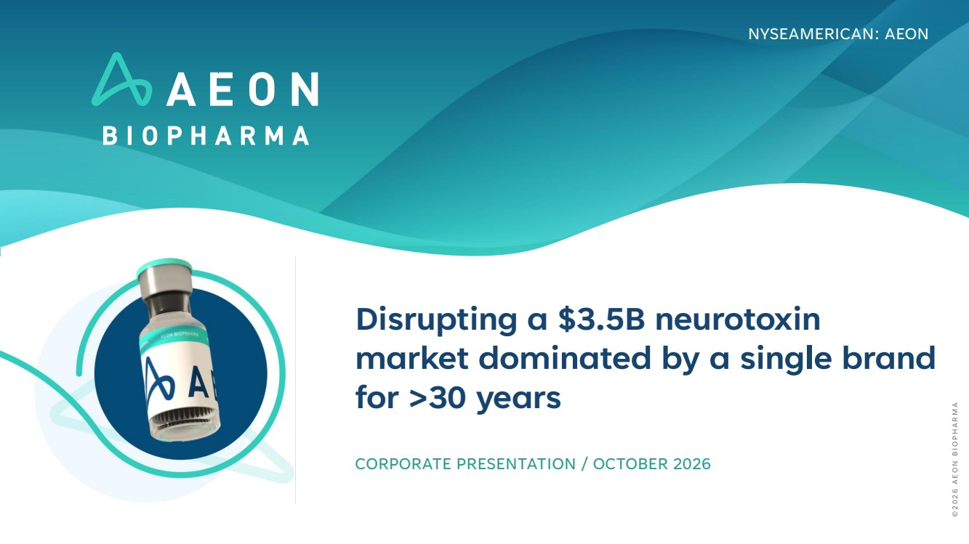 | Disrupting a $3.5B neurotoxin market dominated by a single brand for >30 years CORPORATE PRESENTATION / OCTOBER 2026 NYSEAMERICAN: AEON © 2 0 2 6 A E O N B I O P H A R M A
 | 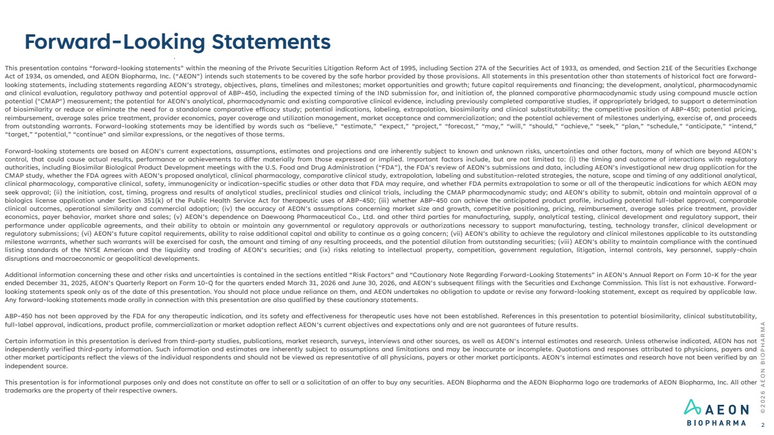 | This presentation contains “forward-looking statements” within the meaning of the Private Securities Litigation Reform Act of 1995, including Section 27A of the Securities Act of 1933, as amended, and Section 21E of the Securities Exchange Act of 1934, as amended, and AEON Biopharma, Inc. (“AEON”) intends such statements to be covered by the safe harbor provided by those provisions. All statements in this presentation other than statements of historical fact are forward-looking statements, including statements regarding AEON’s strategy, objectives, plans, timelines and milestones; market opportunities and growth; future capital requirements and financing; the development, analytical, pharmacodynamic and clinical evaluation, regulatory pathway and potential approval of ABP-450, including the expected timing of the IND submission for, and initiation of, the planned comparative pharmacodynamic study using compound muscle action potential ("CMAP") measurement; the potential for AEON's analytical, pharmacodynamic and existing comparative clinical evidence, including previously completed comparative studies, if appropriately bridged, to support a determination of biosimilarity or reduce or eliminate the need for a standalone comparative efficacy study; potential indications, labeling, extrapolation, biosimilarity and clinical substitutability; the competitive position of ABP-450; potential pricing, reimbursement, average sales price treatment, provider economics, payer coverage and utilization management, market acceptance and commercialization; and the potential achievement of milestones underlying, exercise of, and proceeds from outstanding warrants. Forward-looking statements may be identified by words such as “believe,” “estimate,” “expect,” “project,” “forecast,” “may,” “will,” “should,” “achieve,” “seek,” “plan,” “schedule,” “anticipate,” “intend,” “target,” “potential,” “continue” and similar expressions, or the negatives of those terms. Forward-looking statements are based on AEON’s current expectations, assumptions, estimates and projections and are inherently subject to known and unknown risks, uncertainties and other factors, many of which are beyond AEON’s control, that could cause actual results, performance or achievements to differ materially from those expressed or implied. Important factors include, but are not limited to: (i) the timing and outcome of interactions with regulatory authorities, including Biosimilar Biological Product Development meetings with the U.S. Food and Drug Administration (“FDA”), the FDA’s review of AEON’s submissions and data, including AEON’s investigational new drug application for the CMAP study, whether the FDA agrees with AEON’s proposed analytical, clinical pharmacology, comparative clinical study, extrapolation, labeling and substitution-related strategies, the nature, scope and timing of any additional analytical, clinical pharmacology, comparative clinical, safety, immunogenicity or indication-specific studies or other data that FDA may require, and whether FDA permits extrapolation to some or all of the therapeutic indications for which AEON may seek approval; (ii) the initiation, cost, timing, progress and results of analytical studies, preclinical studies and clinical trials, including the CMAP pharmacodynamic study; and AEON’s ability to submit, obtain and maintain approval of a biologics license application under Section 351(k) of the Public Health Service Act for therapeutic uses of ABP-450; (iii) whether ABP-450 can achieve the anticipated product profile, including potential full-label approval, comparable clinical outcomes, operational similarity and commercial adoption; (iv) the accuracy of AEON’s assumptions concerning market size and growth, competitive positioning, pricing, reimbursement, average sales price treatment, provider economics, payer behavior, market share and sales; (v) AEON’s dependence on Daewoong Pharmaceutical Co., Ltd. and other third parties for manufacturing, supply, analytical testing, clinical development and regulatory support, their performance under applicable agreements, and their ability to obtain or maintain any governmental or regulatory approvals or authorizations necessary to support manufacturing, testing, technology transfer, clinical development or regulatory submissions; (vi) AEON’s future capital requirements, ability to raise additional capital and ability to continue as a going concern; (vii) AEON’s ability to achieve the regulatory and clinical milestones applicable to its outstanding milestone warrants, whether such warrants will be exercised for cash, the amount and timing of any resulting proceeds, and the potential dilution from outstanding securities; (viii) AEON’s ability to maintain compliance with the continued listing standards of the NYSE American and the liquidity and trading of AEON’s securities; and (ix) risks relating to intellectual property, competition, government regulation, litigation, internal controls, key personnel, supply-chain disruptions and macroeconomic or geopolitical developments. Additional information concerning these and other risks and uncertainties is contained in the sections entitled “Risk Factors” and “Cautionary Note Regarding Forward-Looking Statements” in AEON’s Annual Report on Form 10-K for the year ended December 31, 2025, AEON’s Quarterly Report on Form 10-Q for the quarters ended March 31, 2026 and June 30, 2026, and AEON’s subsequent filings with the Securities and Exchange Commission. This list is not exhaustive. Forward-looking statements speak only as of the date of this presentation. You should not place undue reliance on them, and AEON undertakes no obligation to update or revise any forward-looking statement, except as required by applicable law. Any forward-looking statements made orally in connection with this presentation are also qualified by these cautionary statements. ABP-450 has not been approved by the FDA for any therapeutic indication, and its safety and effectiveness for therapeutic uses have not been established. References in this presentation to potential biosimilarity, clinical substitutability, full-label approval, indications, product profile, commercialization or market adoption reflect AEON’s current objectives and expectations only and are not guarantees of future results. Certain information in this presentation is derived from third-party studies, publications, market research, surveys, interviews and other sources, as well as AEON’s internal estimates and research. Unless otherwise indicated, AEON has not independently verified third-party information. Such information and estimates are inherently subject to assumptions and limitations and may be inaccurate or incomplete. Quotations and responses attributed to physicians, payers and other market participants reflect the views of the individual respondents and should not be viewed as representative of all physicians, payers or other market participants. AEON’s internal estimates and research have not been verified by an independent source. This presentation is for informational purposes only and does not constitute an offer to sell or a solicitation of an offer to buy any securities. AEON Biopharma and the AEON Biopharma logo are trademarks of AEON Biopharma, Inc. All other trademarks are the property of their respective owners. Forward-Looking Statements © 2 0 2 6 A E O N B I O P H A R M A 2
 | 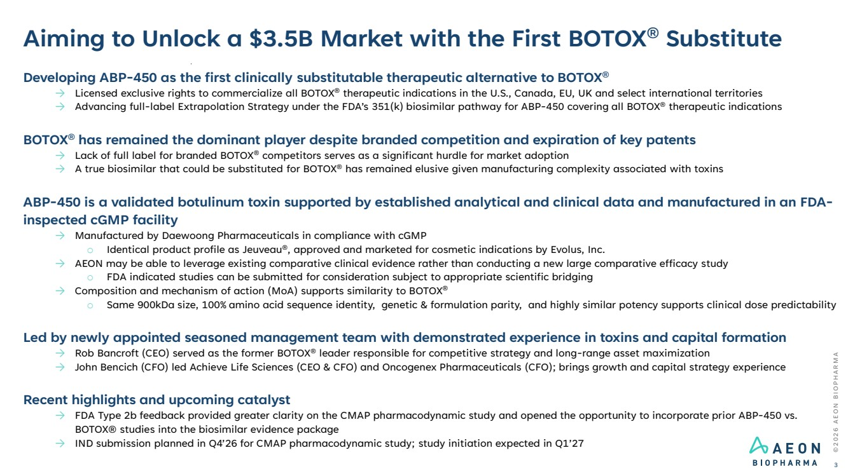 | © 2 0 2 6 A E O N B I O P H A R M A Aiming to Unlock a $3.5B Market with the First BOTOX® Substitute 3 Developing ABP-450 as the first clinically substitutable therapeutic alternative to BOTOX® → Licensed exclusive rights to commercialize all BOTOX® therapeutic indications in the U.S., Canada, EU, UK and select international territories → Advancing full-label Extrapolation Strategy under the FDA’s 351(k) biosimilar pathway for ABP-450 covering all BOTOX® therapeutic indications BOTOX® has remained the dominant player despite branded competition and expiration of key patents → Lack of full label for branded BOTOX® competitors serves as a significant hurdle for market adoption → A true biosimilar that could be substituted for BOTOX® has remained elusive given manufacturing complexity associated with toxins ABP-450 is a validated botulinum toxin supported by established analytical and clinical data and manufactured in an FDA-inspected cGMP facility → Manufactured by Daewoong Pharmaceuticals in compliance with cGMP o Identical product profile as Jeuveau®, approved and marketed for cosmetic indications by Evolus, Inc. → AEON may be able to leverage existing comparative clinical evidence rather than conducting a new large comparative efficacy study o FDA indicated studies can be submitted for consideration subject to appropriate scientific bridging → Composition and mechanism of action (MoA) supports similarity to BOTOX® o Same 900kDa size, 100% amino acid sequence identity, genetic & formulation parity, and highly similar potency supports clinical dose predictability Led by newly appointed seasoned management team with demonstrated experience in toxins and capital formation → Rob Bancroft (CEO) served as the former BOTOX® leader responsible for competitive strategy and long-range asset maximization → John Bencich (CFO) led Achieve Life Sciences (CEO & CFO) and Oncogenex Pharmaceuticals (CFO); brings growth and capital strategy experience Recent highlights and upcoming catalyst → FDA Type 2b feedback provided greater clarity on the CMAP pharmacodynamic study and opened the opportunity to incorporate prior ABP-450 vs. BOTOX® studies into the biosimilar evidence package → IND submission planned in Q4’26 for CMAP pharmacodynamic study; study initiation expected in Q1’27
 | 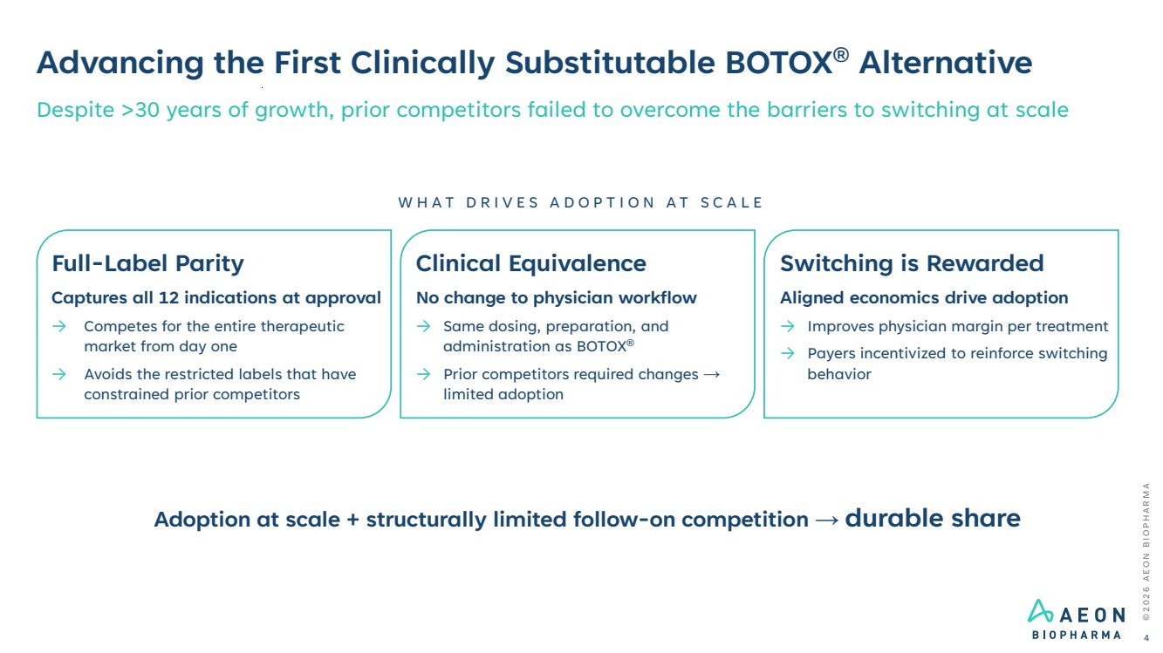 | © 2 0 2 6 A E O N B I O P H A R M A Advancing the First Clinically Substitutable BOTOX® Alternative 4 Despite >30 years of growth, prior competitors failed to overcome the barriers to switching at scale Full-Label Parity Captures all 12 indications at approval → Competes for the entire therapeutic market from day one → Avoids the restricted labels that have constrained prior competitors Clinical Equivalence No change to physician workflow → Same dosing, preparation, and administration as BOTOX® → Prior competitors required changes → limited adoption Switching is Rewarded Aligned economics drive adoption → Improves physician margin per treatment → Payers incentivized to reinforce switching behavior W H A T D R I V E S A D O P T I O N A T S C A L E Adoption at scale + structurally limited follow-on competition → durable share
 | 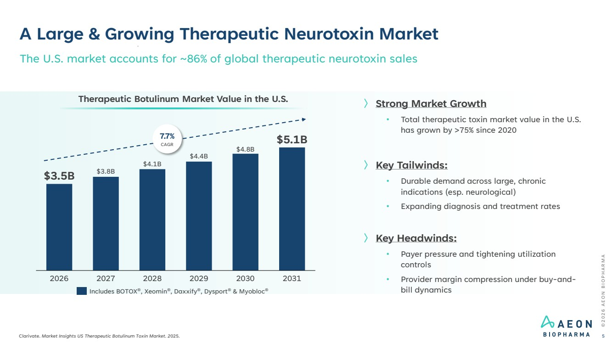 | © 2 0 2 6 A E O N B I O P H A R M A Clarivate. Market Insights US Therapeutic Botulinum Toxin Market. 2025. 5 The U.S. market accounts for ~86% of global therapeutic neurotoxin sales 2026 2027 2028 2029 2030 2031 $3.5B $3.8B $4.1B $4.4B $4.8B $5.1B Therapeutic Botulinum Market Value in the U.S. 7.7% CAGR Includes BOTOX®, Xeomin®, Daxxify®, Dysport® & Myobloc® 〉 Strong Market Growth • Total therapeutic toxin market value in the U.S. has grown by >75% since 2020 〉 Key Tailwinds: • Durable demand across large, chronic indications (esp. neurological) • Expanding diagnosis and treatment rates 〉 Key Headwinds: • Payer pressure and tightening utilization controls • Provider margin compression under buy-and-bill dynamics A Large & Growing Therapeutic Neurotoxin Market
 | 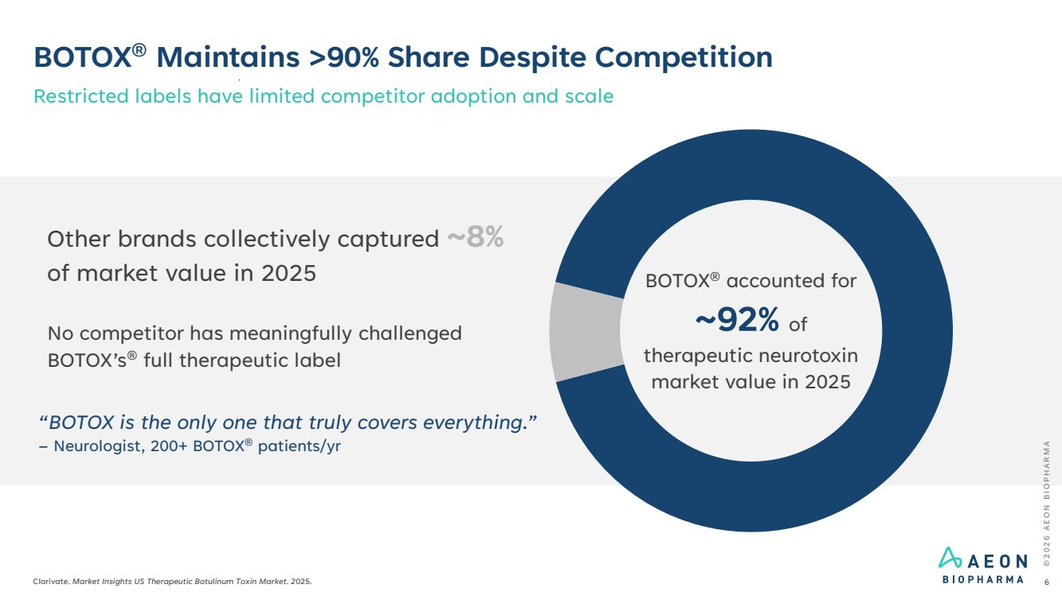 | BOTOX® Maintains >90% Share Despite Competition Restricted labels have limited competitor adoption and scale © 2 0 2 6 A E O N B I O P H A R M A Clarivate. Market Insights US Therapeutic Botulinum Toxin Market. 2025. 6 Other brands collectively captured ~8% of market value in 2025 No competitor has meaningfully challenged BOTOX’s® full therapeutic label BOTOX® accounted for ~92% of therapeutic neurotoxin market value in 2025 “BOTOX is the only one that truly covers everything.” – Neurologist, 200+ BOTOX® patients/yr
 | 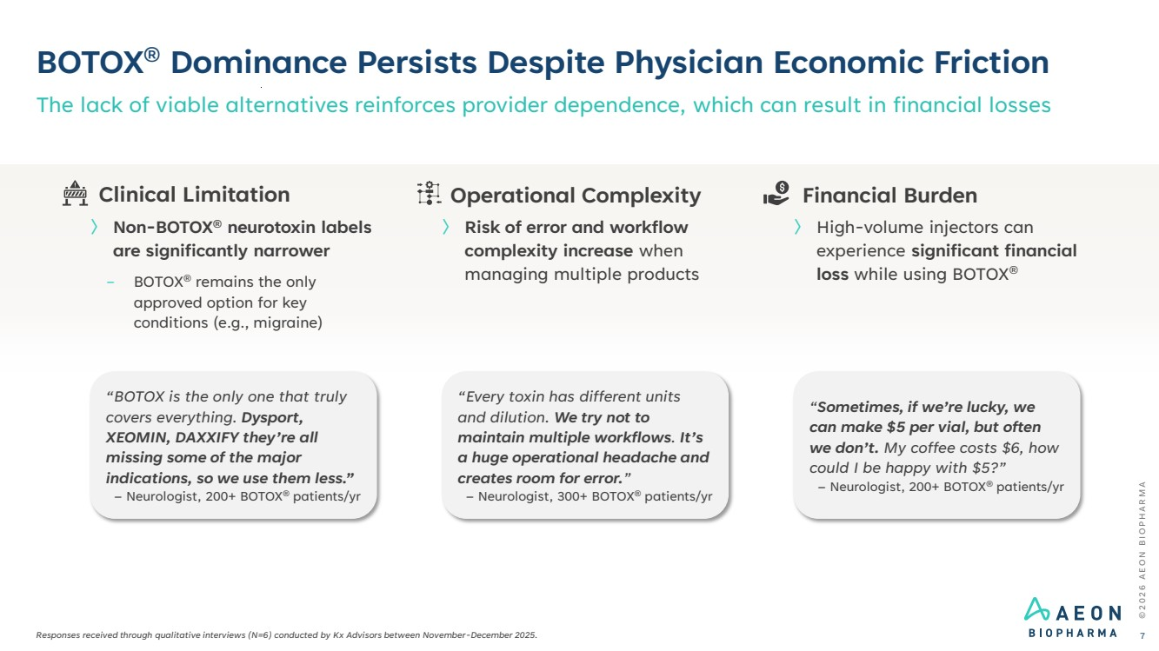 | © 2 0 2 6 A E O N B I O P H A R M A BOTOX® Dominance Persists Despite Physician Economic Friction Responses received through qualitative interviews (N=6) conducted by Kx Advisors between November-December 2025. The lack of viable alternatives reinforces provider dependence, which can result in financial losses 7 “Sometimes, if we’re lucky, we can make $5 per vial, but often we don’t. My coffee costs $6, how could I be happy with $5?” – Neurologist, 200+ BOTOX® patients/yr “Every toxin has different units and dilution. We try not to maintain multiple workflows. It’s a huge operational headache and creates room for error.” – Neurologist, 300+ BOTOX® patients/yr “BOTOX is the only one that truly covers everything. Dysport, XEOMIN, DAXXIFY they’re all missing some of the major indications, so we use them less.” – Neurologist, 200+ BOTOX® patients/yr Financial Burden 〉 High-volume injectors can experience significant financial loss while using BOTOX® Operational Complexity 〉 Risk of error and workflow complexity increase when managing multiple products Clinical Limitation 〉 Non-BOTOX® neurotoxin labels are significantly narrower − BOTOX® remains the only approved option for key conditions (e.g., migraine)
 | 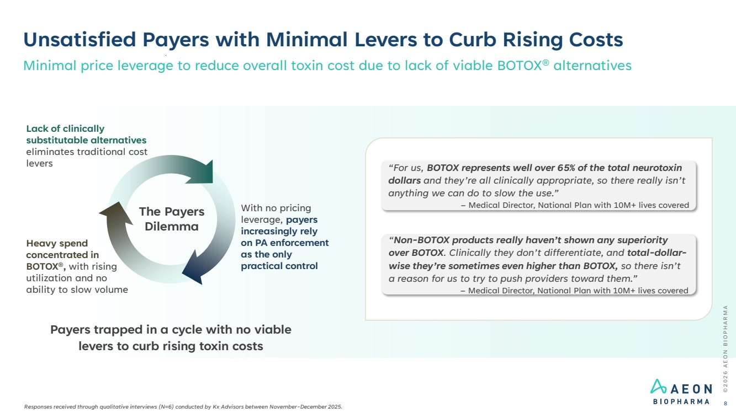 | Heavy spend concentrated in BOTOX®, with rising utilization and no ability to slow volume The Payers Dilemma Unsatisfied Payers with Minimal Levers to Curb Rising Costs © 2 0 2 6 A E O N B I O P H A R M A 8 Payers trapped in a cycle with no viable levers to curb rising toxin costs “For us, BOTOX represents well over 65% of the total neurotoxin dollars and they’re all clinically appropriate, so there really isn’t anything we can do to slow the use.” – Medical Director, National Plan with 10M+ lives covered “Non-BOTOX products really haven’t shown any superiority over BOTOX. Clinically they don’t differentiate, and total-dollar-wise they’re sometimes even higher than BOTOX, so there isn’t a reason for us to try to push providers toward them.” – Medical Director, National Plan with 10M+ lives covered Minimal price leverage to reduce overall toxin cost due to lack of viable BOTOX® alternatives Lack of clinically substitutable alternatives eliminates traditional cost levers With no pricing leverage, payers increasingly rely on PA enforcement as the only practical control Responses received through qualitative interviews (N=6) conducted by Kx Advisors between November-December 2025.
 | 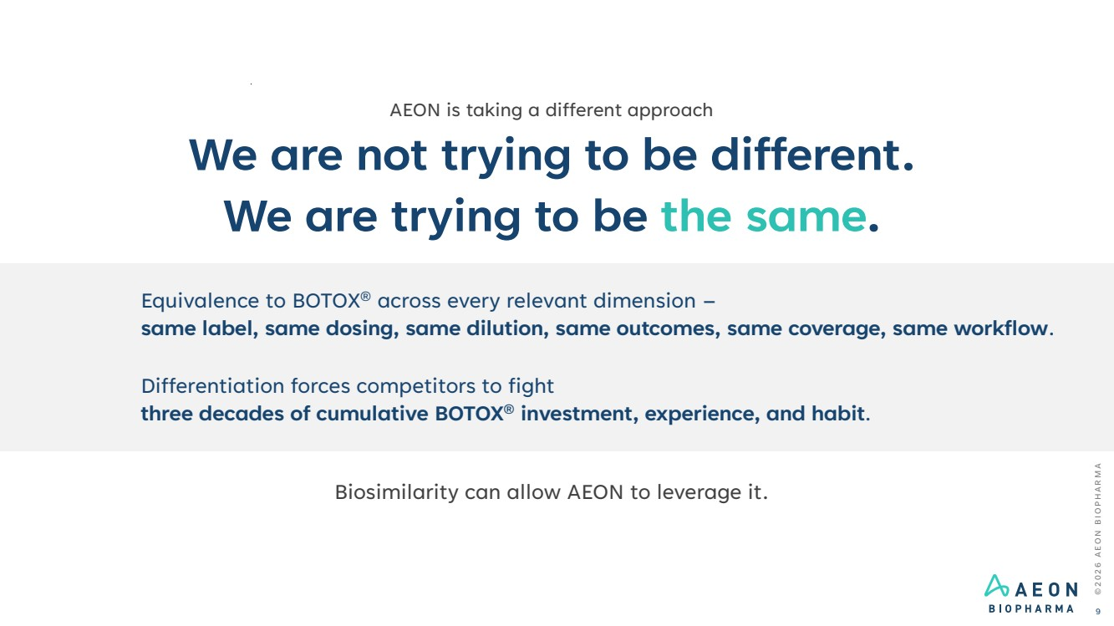 | © 2 0 2 6 A E O N B I O P H A R M A 9 AEON is taking a different approach We are not trying to be different. We are trying to be the same. Equivalence to BOTOX® across every relevant dimension – same label, same dosing, same dilution, same outcomes, same coverage, same workflow. Differentiation forces competitors to fight three decades of cumulative BOTOX® investment, experience, and habit. Biosimilarity can allow AEON to leverage it.
 | 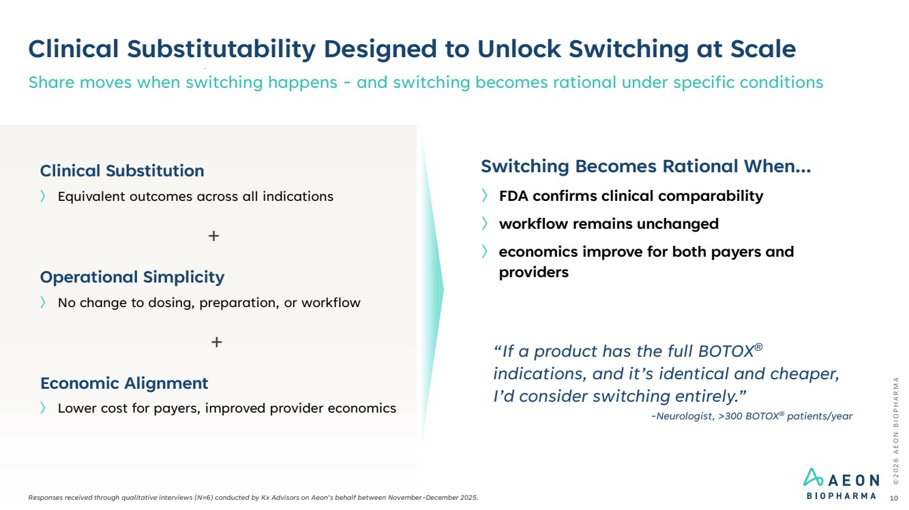 | Clinical Substitutability Designed to Unlock Switching at Scale Share moves when switching happens - and switching becomes rational under specific conditions © 2 0 2 6 A E O N B I O P H A R M A 10 〉 Lower cost for payers, improved provider economics Economic Alignment 〉 No change to dosing, preparation, or workflow Operational Simplicity 〉 Equivalent outcomes across all indications Clinical Substitution Switching Becomes Rational When... 〉 FDA confirms clinical comparability 〉 workflow remains unchanged 〉 economics improve for both payers and providers + + “If a product has the full BOTOX® indications, and it’s identical and cheaper, I’d consider switching entirely.” -Neurologist, >300 BOTOX® patients/year Responses received through qualitative interviews (N=6) conducted by Kx Advisors on Aeon’s behalf between November-December 2025.
 | 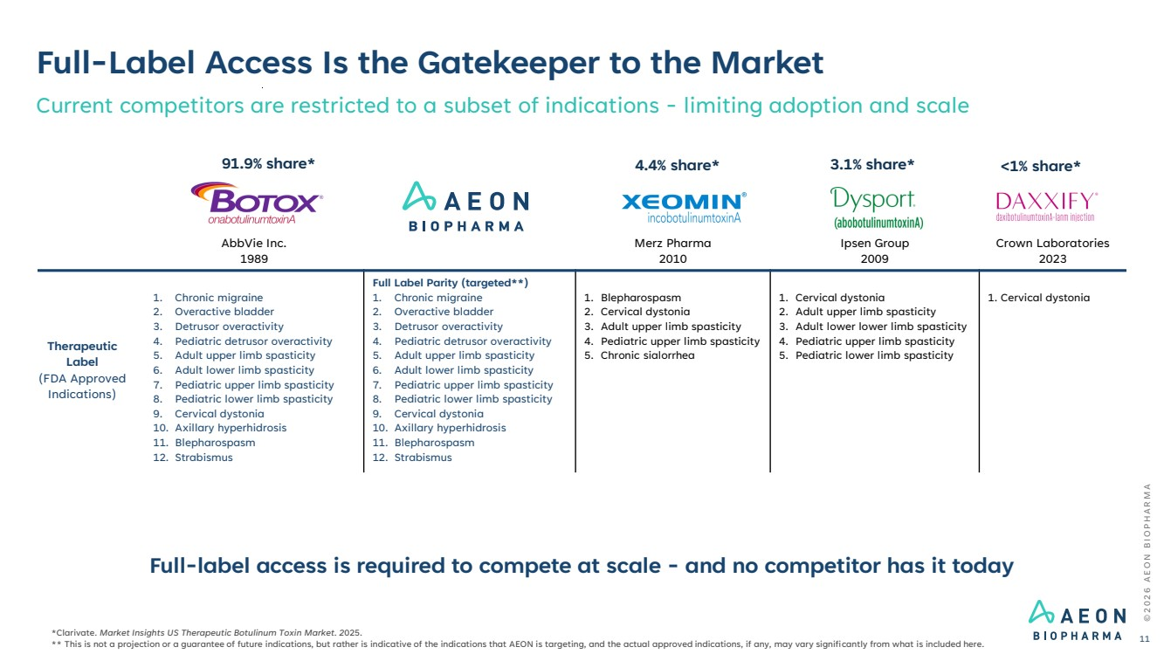 | AbbVie Inc. 1989 Merz Pharma 2010 Ipsen Group 2009 Crown Laboratories 2023 Therapeutic Label (FDA Approved Indications) 1. Chronic migraine 2. Overactive bladder 3. Detrusor overactivity 4. Pediatric detrusor overactivity 5. Adult upper limb spasticity 6. Adult lower limb spasticity 7. Pediatric upper limb spasticity 8. Pediatric lower limb spasticity 9. Cervical dystonia 10. Axillary hyperhidrosis 11. Blepharospasm 12. Strabismus Full Label Parity (targeted**) 1. Chronic migraine 2. Overactive bladder 3. Detrusor overactivity 4. Pediatric detrusor overactivity 5. Adult upper limb spasticity 6. Adult lower limb spasticity 7. Pediatric upper limb spasticity 8. Pediatric lower limb spasticity 9. Cervical dystonia 10. Axillary hyperhidrosis 11. Blepharospasm 12. Strabismus 1. Blepharospasm 2. Cervical dystonia 3. Adult upper limb spasticity 4. Pediatric upper limb spasticity 5. Chronic sialorrhea 1. Cervical dystonia 2. Adult upper limb spasticity 3. Adult lower lower limb spasticity 4. Pediatric upper limb spasticity 5. Pediatric lower limb spasticity 1. Cervical dystonia Full-Label Access Is the Gatekeeper to the Market Current competitors are restricted to a subset of indications - limiting adoption and scale Full-label access is required to compete at scale - and no competitor has it today © 2 0 2 6 A E O N B I O P H A R M A 11 *Clarivate. Market Insights US Therapeutic Botulinum Toxin Market. 2025. ** This is not a projection or a guarantee of future indications, but rather is indicative of the indications that AEON is targeting, and the actual approved indications, if any, may vary significantly from what is included here. 91.9% share* 4.4% share* 3.1% share* <1% share*
 | 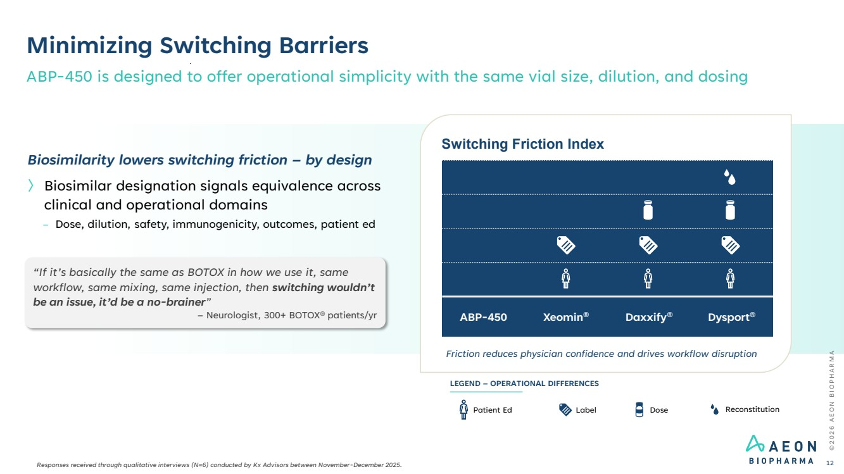 | © 2 0 2 6 A E O N B I O P H A R M A Minimizing Switching Barriers ABP-450 is designed to offer operational simplicity with the same vial size, dilution, and dosing 12 Switching Friction Index Friction reduces physician confidence and drives workflow disruption ABP-450 Xeomin® Daxxify® Dysport® Label Dose Reconstitution LEGEND – OPERATIONAL DIFFERENCES Patient Ed Biosimilarity lowers switching friction – by design 〉 Biosimilar designation signals equivalence across clinical and operational domains – Dose, dilution, safety, immunogenicity, outcomes, patient ed “If it’s basically the same as BOTOX in how we use it, same workflow, same mixing, same injection, then switching wouldn’t be an issue, it’d be a no-brainer” – Neurologist, 300+ BOTOX® patients/yr Responses received through qualitative interviews (N=6) conducted by Kx Advisors between November-December 2025.
 | 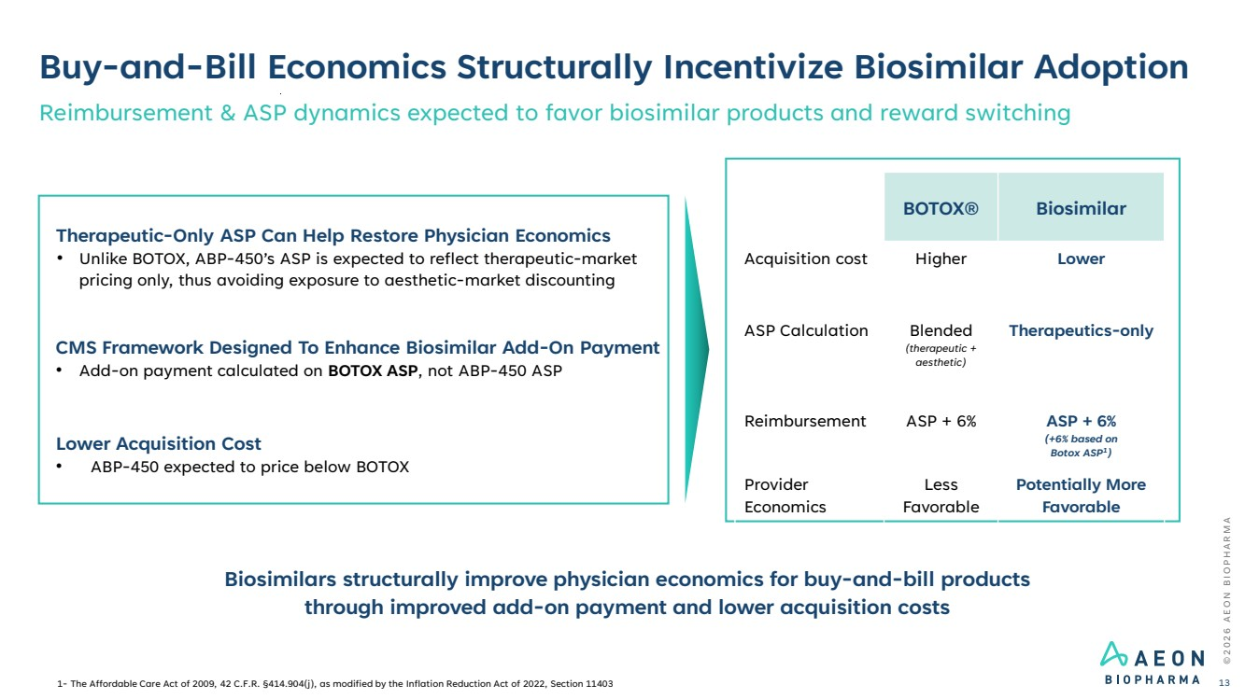 | Buy-and-Bill Economics Structurally Incentivize Biosimilar Adoption Reimbursement & ASP dynamics expected to favor biosimilar products and reward switching © 2 0 2 6 A E O N B I O P H A R M A 13 Biosimilars structurally improve physician economics for buy-and-bill products through improved add-on payment and lower acquisition costs Therapeutic-Only ASP Can Help Restore Physician Economics • Unlike BOTOX, ABP-450’s ASP is expected to reflect therapeutic-market pricing only, thus avoiding exposure to aesthetic-market discounting CMS Framework Designed To Enhance Biosimilar Add-On Payment • Add-on payment calculated on BOTOX ASP, not ABP-450 ASP Lower Acquisition Cost • ABP-450 expected to price below BOTOX BOTOX® Biosimilar Acquisition cost Higher Lower ASP Calculation Blended (therapeutic + aesthetic) Therapeutics-only Reimbursement ASP + 6% ASP + 6% (+6% based on Botox ASP1 ) Provider Economics Less Favorable Potentially More Favorable 1- The Affordable Care Act of 2009, 42 C.F.R. §414.904(j), as modified by the Inflation Reduction Act of 2022, Section 11403
 | 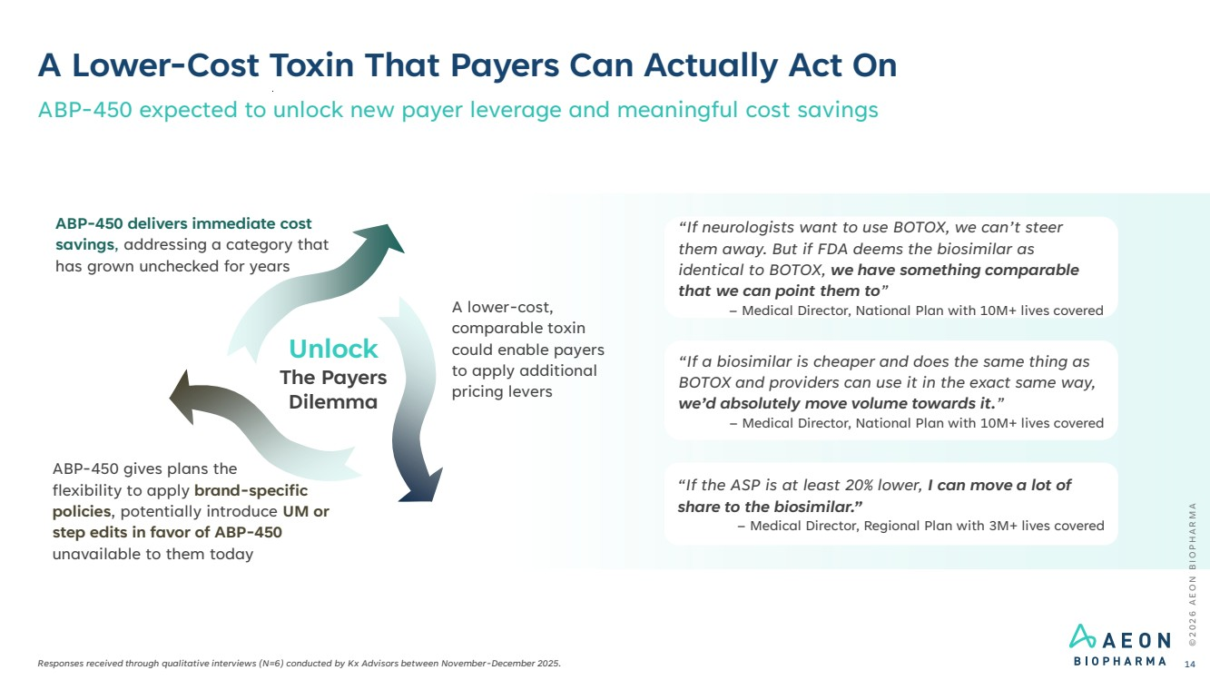 | © 2 0 2 6 A E O N B I O P H A R M A A Lower-Cost Toxin That Payers Can Actually Act On Responses received through qualitative interviews (N=6) conducted by Kx Advisors between November-December 2025. ABP-450 expected to unlock new payer leverage and meaningful cost savings 14 “If neurologists want to use BOTOX, we can’t steer them away. But if FDA deems the biosimilar as identical to BOTOX, we have something comparable that we can point them to” – Medical Director, National Plan with 10M+ lives covered “If a biosimilar is cheaper and does the same thing as BOTOX and providers can use it in the exact same way, we’d absolutely move volume towards it.” – Medical Director, National Plan with 10M+ lives covered “If the ASP is at least 20% lower, I can move a lot of share to the biosimilar.” – Medical Director, Regional Plan with 3M+ lives covered ABP-450 gives plans the flexibility to apply brand-specific policies, potentially introduce UM or step edits in favor of ABP-450 unavailable to them today A lower-cost, comparable toxin could enable payers to apply additional pricing levers ABP-450 delivers immediate cost savings, addressing a category that has grown unchecked for years Unlock The Payers Dilemma
 | 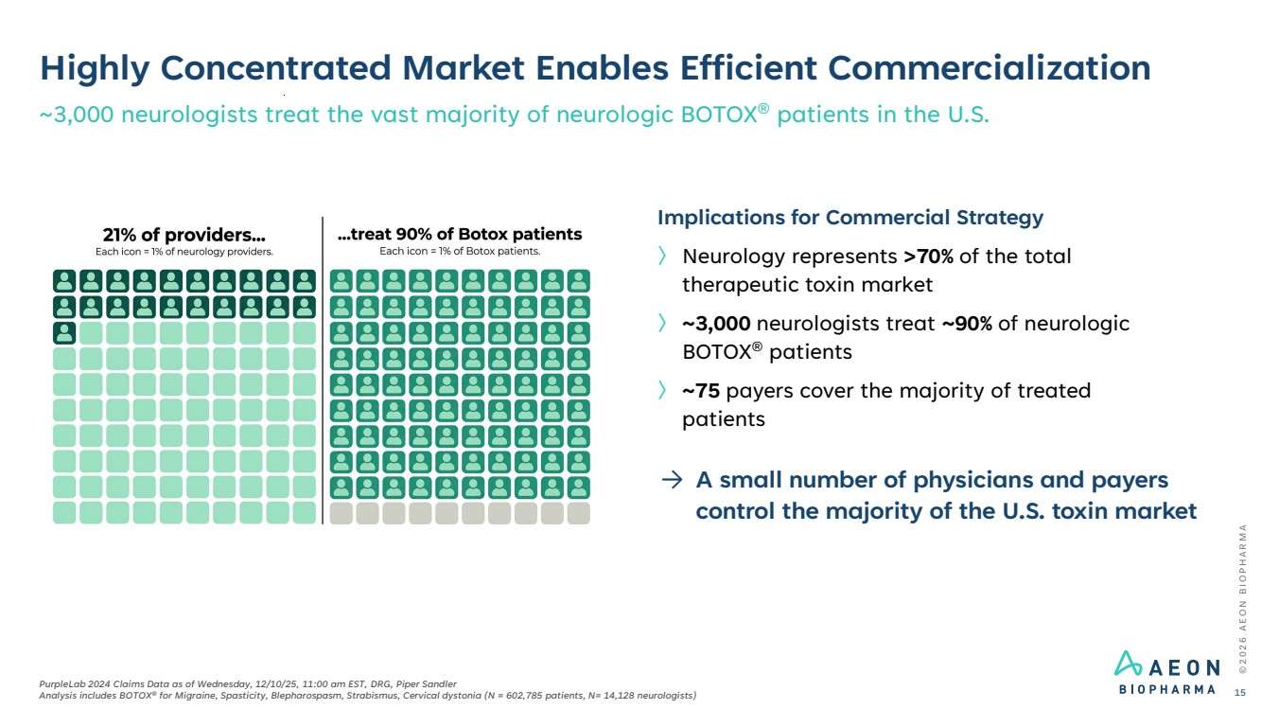 | Highly Concentrated Market Enables Efficient Commercialization ~3,000 neurologists treat the vast majority of neurologic BOTOX® patients in the U.S. © 2 0 2 6 A E O N B I O P H A R M A PurpleLab 2024 Claims Data as of Wednesday, 12/10/25, 11:00 am EST, DRG, Piper Sandler Analysis includes BOTOX® for Migraine, Spasticity, Blepharospasm, Strabismus, Cervical dystonia (N = 602,785 patients, N= 14,128 neurologists) 15 Implications for Commercial Strategy 〉 Neurology represents >70% of the total therapeutic toxin market 〉 ~3,000 neurologists treat ~90% of neurologic BOTOX® patients 〉 ~75 payers cover the majority of treated patients → A small number of physicians and payers control the majority of the U.S. toxin market
 | 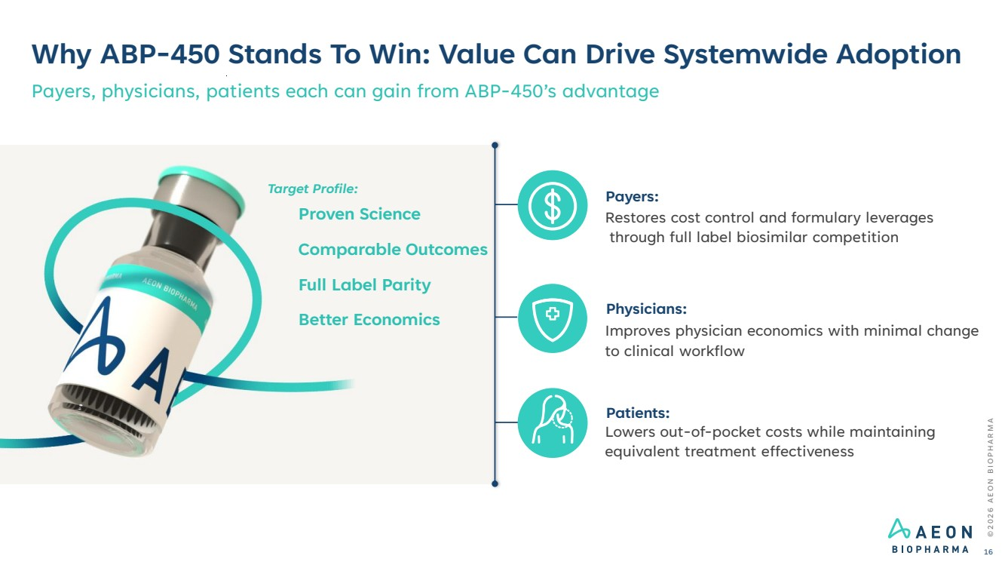 | Why ABP-450 Stands To Win: Value Can Drive Systemwide Adoption Payers, physicians, patients each can gain from ABP-450’s advantage Payers: Restores cost control and formulary leverages through full label biosimilar competition Physicians: Improves physician economics with minimal change to clinical workflow Patients: Lowers out-of-pocket costs while maintaining equivalent treatment effectiveness Proven Science Comparable Outcomes Full Label Parity Better Economics © 2 0 2 6 A E O N B I O P H A R M A 16 Target Profile:
 | 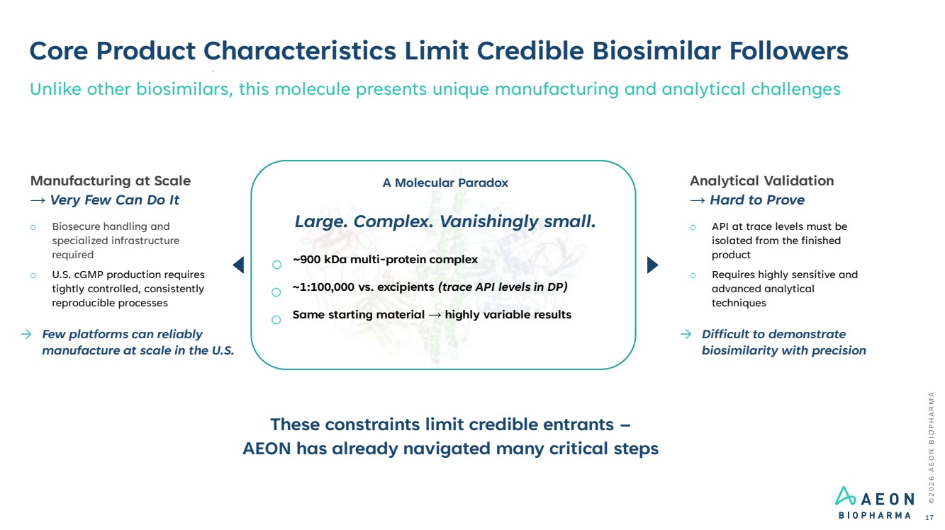 | © 2 0 2 6 A E O N B I O P H A R M A Core Product Characteristics Limit Credible Biosimilar Followers 17 Unlike other biosimilars, this molecule presents unique manufacturing and analytical challenges A Molecular Paradox Large. Complex. Vanishingly small. o ~900 kDa multi-protein complex o ~1:100,000 vs. excipients (trace API levels in DP) o Same starting material → highly variable results These constraints limit credible entrants – AEON has already navigated many critical steps Manufacturing at Scale → Very Few Can Do It o Biosecure handling and specialized infrastructure required o U.S. cGMP production requires tightly controlled, consistently reproducible processes → Few platforms can reliably manufacture at scale in the U.S. Analytical Validation → Hard to Prove o API at trace levels must be isolated from the finished product o Requires highly sensitive and advanced analytical techniques → Difficult to demonstrate biosimilarity with precision
 | 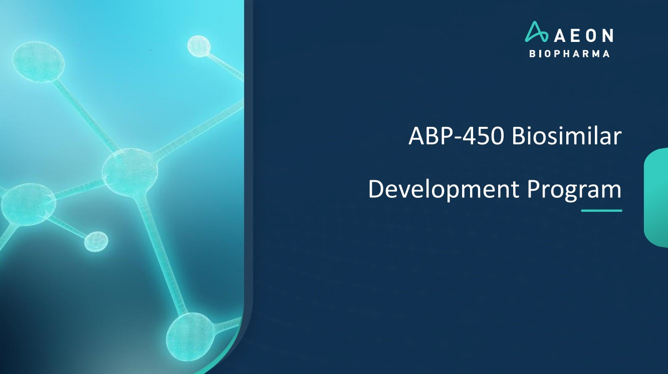 | ABP-450 Biosimilar Development Program
 | 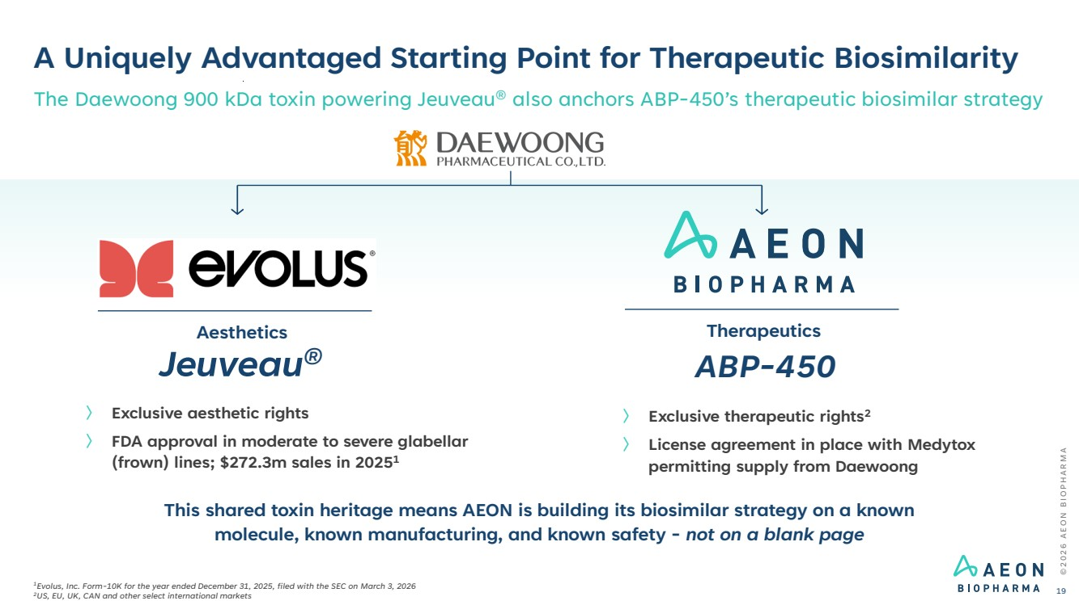 | A Uniquely Advantaged Starting Point for Therapeutic Biosimilarity 〉 Exclusive aesthetic rights 〉 FDA approval in moderate to severe glabellar (frown) lines; $272.3m sales in 20251 Jeuveau® ABP-450 Aesthetics Therapeutics 〉 Exclusive therapeutic rights2 〉 License agreement in place with Medytox permitting supply from Daewoong © 2 0 2 6 A E O N B I O P H A R M A 19 The Daewoong 900 kDa toxin powering Jeuveau® also anchors ABP-450’s therapeutic biosimilar strategy This shared toxin heritage means AEON is building its biosimilar strategy on a known molecule, known manufacturing, and known safety - not on a blank page 1Evolus, Inc. Form-10K for the year ended December 31, 2025, filed with the SEC on March 3, 2026 2US, EU, UK, CAN and other select international markets
 | 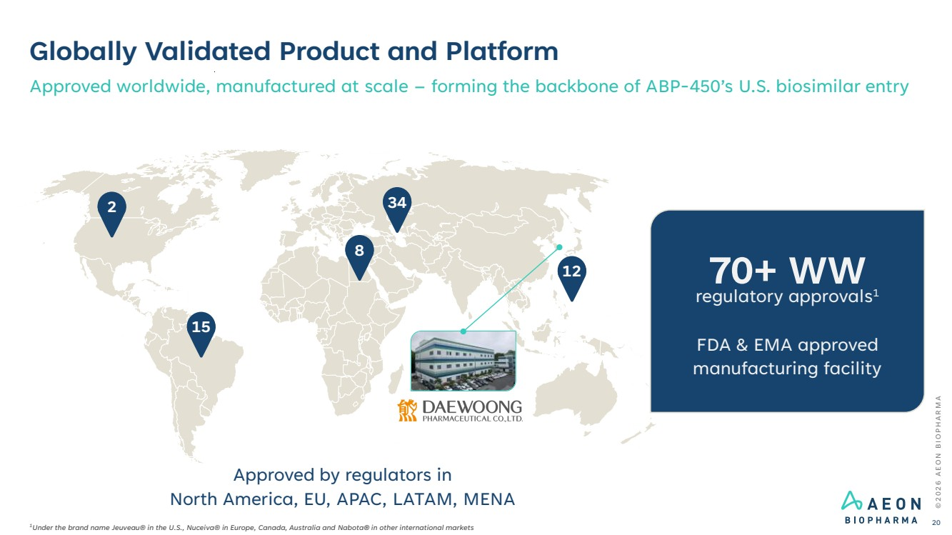 | Globally Validated Product and Platform Approved worldwide, manufactured at scale – forming the backbone of ABP-450’s U.S. biosimilar entry 2 15 8 34 12 Approved by regulators in North America, EU, APAC, LATAM, MENA © 2 0 2 6 A E O N B I O P H A R M A 20 1Under the brand name Jeuveau® in the U.S., Nuceiva® in Europe, Canada, Australia and Nabota® in other international markets regulatory approvals 70+ WW 1 FDA & EMA approved manufacturing facility
 | 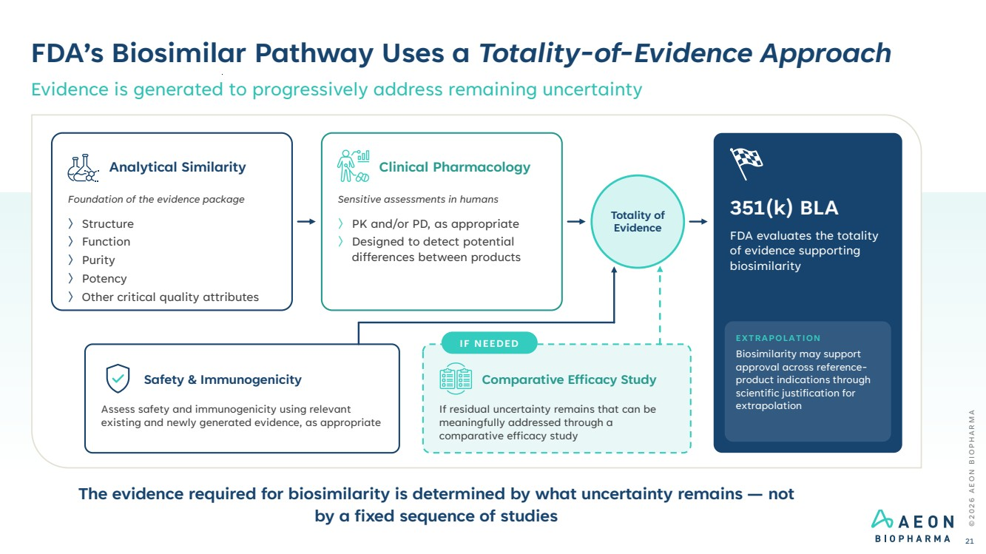 | FDA’s Biosimilar Pathway Uses a Totality-of-Evidence Approach Evidence is generated to progressively address remaining uncertainty © 2 0 2 6 A E O N B I O P H A R M A 21 Analytical Similarity Foundation of the evidence package 〉Structure 〉Function 〉Purity 〉Potency 〉Other critical quality attributes Clinical Pharmacology Sensitive assessments in humans 〉PK and/or PD, as appropriate 〉Designed to detect potential differences between products Totality of Evidence 351(k) BLA FDA evaluates the totality of evidence supporting biosimilarity EXTRAPOLATION Biosimilarity may support approval across reference-product indications through scientific justification for extrapolation Safety & Immunogenicity Assess safety and immunogenicity using relevant existing and newly generated evidence, as appropriate IF NEEDED Comparative Efficacy Study If residual uncertainty remains that can be meaningfully addressed through a comparative efficacy study The evidence required for biosimilarity is determined by what uncertainty remains — not by a fixed sequence of studies
 | 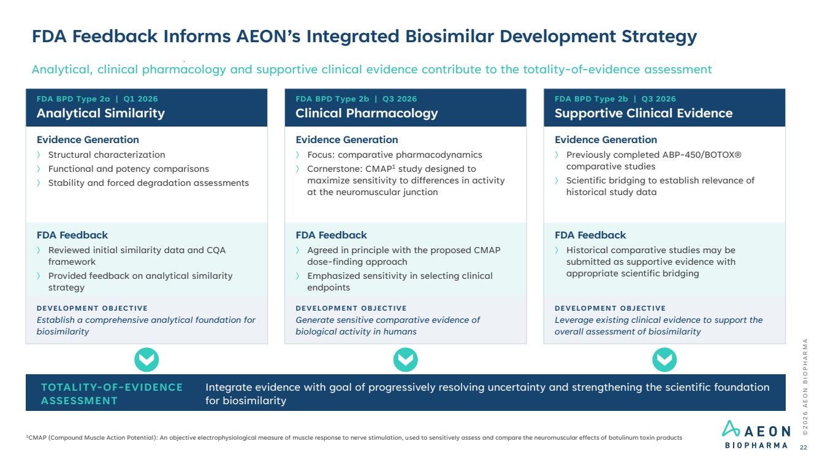 | FDA Feedback Informs AEON’s Integrated Biosimilar Development Strategy Analytical, clinical pharmacology and supportive clinical evidence contribute to the totality-of-evidence assessment © 2 0 2 6 A E O N B I O P H A R M A 22 FDA BPD Type 2a | Q1 2026 Analytical Similarity Evidence Generation 〉 Structural characterization 〉 Functional and potency comparisons 〉 Stability and forced degradation assessments FDA Feedback 〉 Reviewed initial similarity data and CQA framework 〉 Provided feedback on analytical similarity strategy DEVELOPMENT OBJECTIVE Establish a comprehensive analytical foundation for biosimilarity FDA BPD Type 2b | Q3 2026 Clinical Pharmacology Evidence Generation 〉 Focus: comparative pharmacodynamics 〉 Cornerstone: CMAP1 study designed to maximize sensitivity to differences in activity at the neuromuscular junction FDA Feedback 〉 Agreed in principle with the proposed CMAP dose-finding approach 〉 Emphasized sensitivity in selecting clinical endpoints DEVELOPMENT OBJECTIVE Generate sensitive comparative evidence of biological activity in humans FDA BPD Type 2b | Q3 2026 Supportive Clinical Evidence Evidence Generation 〉 Previously completed ABP-450/BOTOX® comparative studies 〉 Scientific bridging to establish relevance of historical study data FDA Feedback 〉 Historical comparative studies may be submitted as supportive evidence with appropriate scientific bridging DEVELOPMENT OBJECTIVE Leverage existing clinical evidence to support the overall assessment of biosimilarity TOTALITY-OF-EVIDENCE ASSESSMENT Integrate evidence with goal of progressively resolving uncertainty and strengthening the scientific foundation for biosimilarity 1CMAP (Compound Muscle Action Potential): An objective electrophysiological measure of muscle response to nerve stimulation, used to sensitively assess and compare the neuromuscular effects of botulinum toxin products
 | 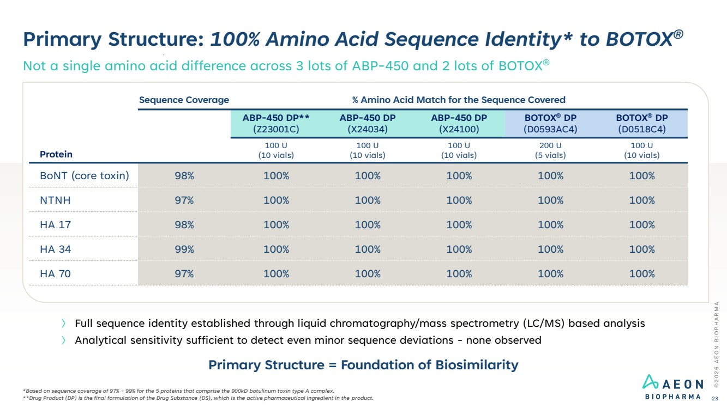 | Primary Structure: 100% Amino Acid Sequence Identity* to BOTOX® Not a single amino acid difference across 3 lots of ABP-450 and 2 lots of BOTOX® © 2 0 2 6 A E O N B I O P H A R M A 23 *Based on sequence coverage of 97% - 99% for the 5 proteins that comprise the 900kD botulinum toxin type A complex. **Drug Product (DP) is the final formulation of the Drug Substance (DS), which is the active pharmaceutical ingredient in the product. 〉 Full sequence identity established through liquid chromatography/mass spectrometry (LC/MS) based analysis 〉 Analytical sensitivity sufficient to detect even minor sequence deviations - none observed Protein Sequence Coverage % Amino Acid Match for the Sequence Covered ABP-450 DP** (Z23001C) ABP-450 DP (X24034) ABP-450 DP (X24100) BOTOX® DP (D0593AC4) BOTOX® DP (D0518C4) 100 U (10 vials) 100 U (10 vials) 100 U (10 vials) 200 U (5 vials) 100 U (10 vials) BoNT (core toxin) 98% 100% 100% 100% 100% 100% NTNH 97% 100% 100% 100% 100% 100% HA 17 98% 100% 100% 100% 100% 100% HA 34 99% 100% 100% 100% 100% 100% HA 70 97% 100% 100% 100% 100% 100% Primary Structure = Foundation of Biosimilarity
 | 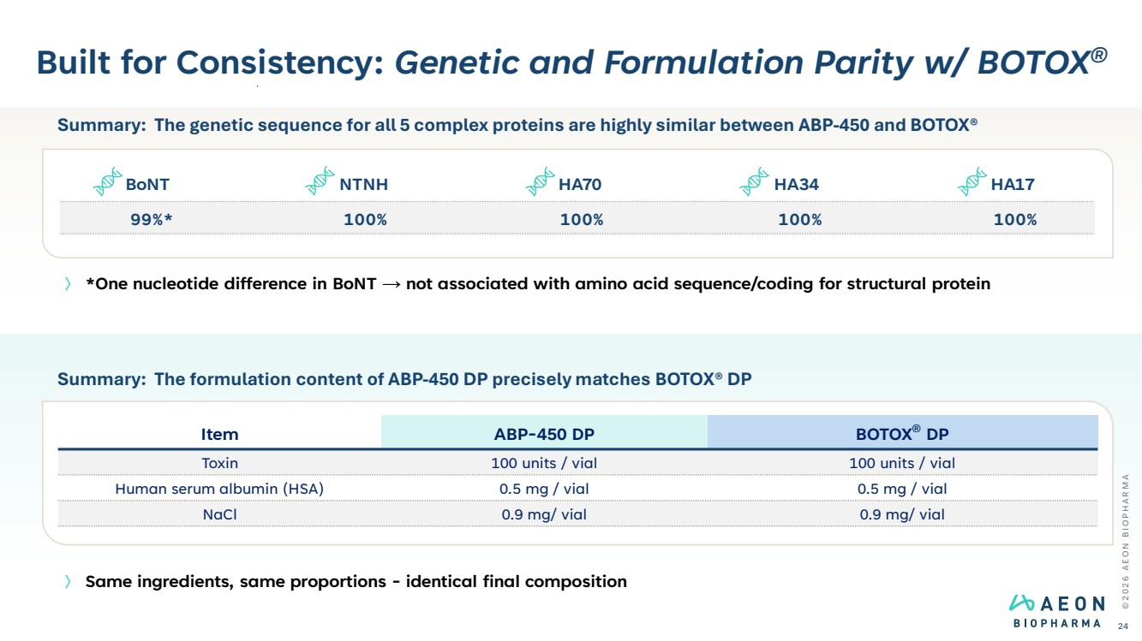 | Built for Consistency: Genetic and Formulation Parity w/ BOTOX® © 2 0 2 6 A E O N B I O P H A R M A 24 〉 *One nucleotide difference in BoNT → not associated with amino acid sequence/coding for structural protein 〉 Same ingredients, same proportions - identical final composition Summary: The formulation content of ABP-450 DP precisely matches BOTOX® DP Item ABP-450 DP BOTOX® DP Toxin 100 units / vial 100 units / vial Human serum albumin (HSA) 0.5 mg / vial 0.5 mg / vial NaCl 0.9 mg/ vial 0.9 mg/ vial Summary: The genetic sequence for all 5 complex proteins are highly similar between ABP-450 and BOTOX® BoNT NTNH HA70 HA34 HA17 99%* 100% 100% 100% 100%
 | 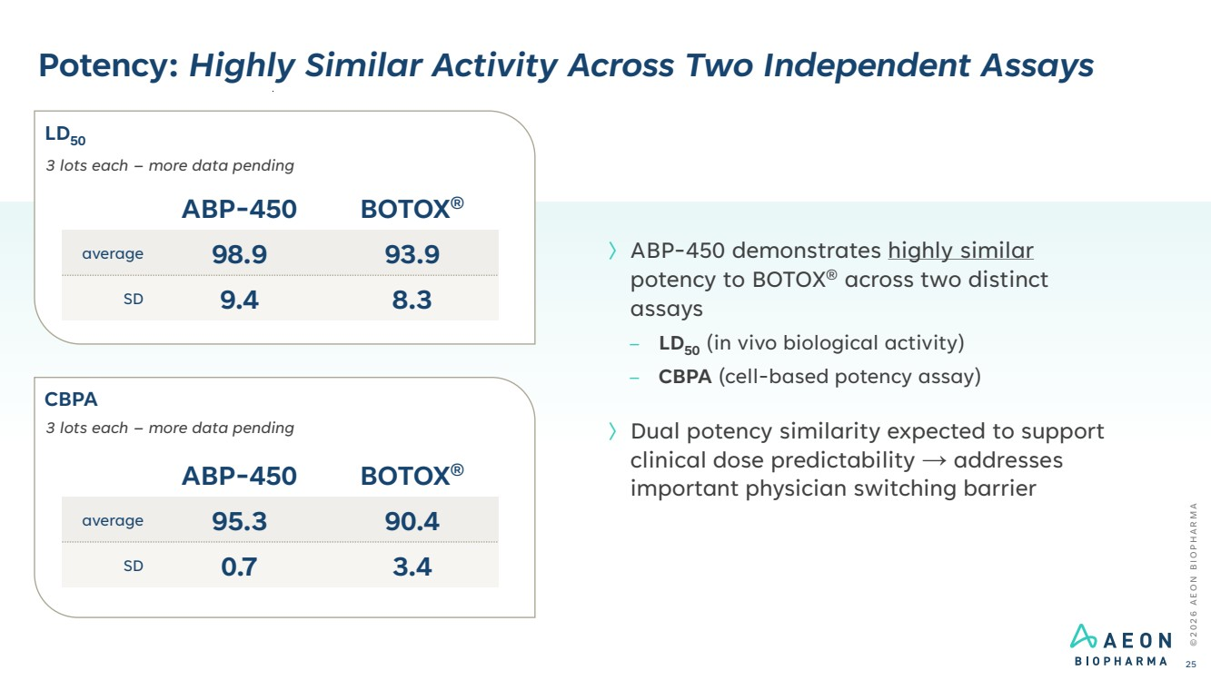 | Potency: Highly Similar Activity Across Two Independent Assays © 2 0 2 6 A E O N B I O P H A R M A 25 〉ABP-450 demonstrates highly similar potency to BOTOX® across two distinct assays – LD50 (in vivo biological activity) – CBPA (cell-based potency assay) 〉Dual potency similarity expected to support clinical dose predictability → addresses important physician switching barrier ABP-450 BOTOX® average 98.9 93.9 SD 9.4 8.3 3 lots each – more data pending ABP-450 BOTOX® average 95.3 90.4 SD 0.7 3.4 3 lots each – more data pending LD50 CBPA
 | 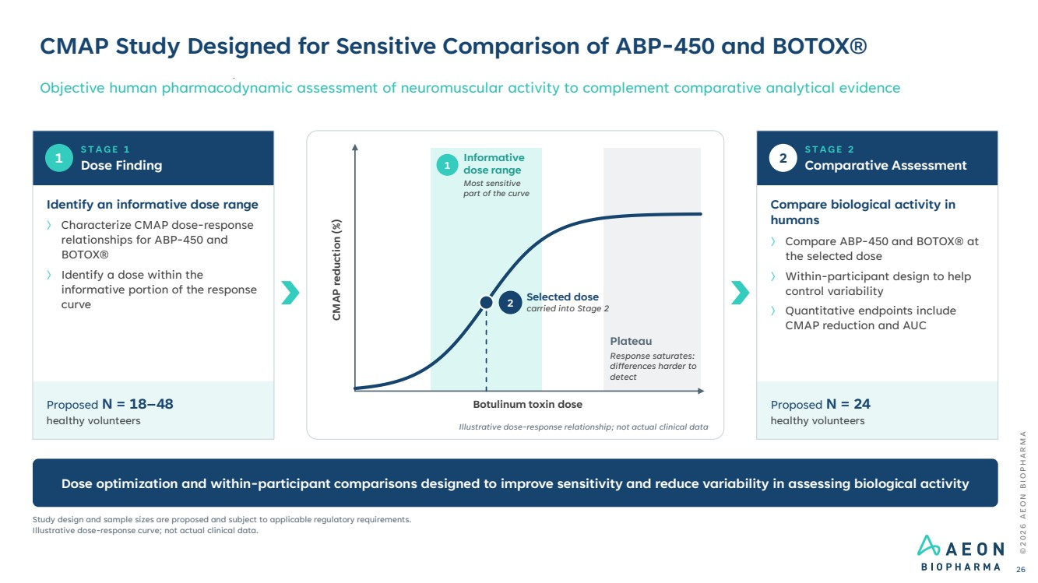 | CMAP Study Designed for Sensitive Comparison of ABP-450 and BOTOX® Objective human pharmacodynamic assessment of neuromuscular activity to complement comparative analytical evidence © 2 0 2 6 A E O N B I O P H A R M A 26 1 S T A G E 1 Dose Finding Identify an informative dose range 〉 Characterize CMAP dose-response relationships for ABP-450 and BOTOX® 〉 Identify a dose within the informative portion of the response curve Proposed N = 18–48 healthy volunteers 2 S T A G E 2 Comparative Assessment Compare biological activity in humans 〉 Compare ABP-450 and BOTOX® at the selected dose 〉 Within-participant design to help control variability 〉 Quantitative endpoints include CMAP reduction and AUC Proposed N = 24 healthy volunteers 1 Informative dose range Most sensitive part of the curve Plateau Response saturates: differences harder to detect Botulinum toxin dose CMAP reduction (%) 2 Selected dose carried into Stage 2 Illustrative dose-response relationship; not actual clinical data Dose optimization and within-participant comparisons designed to improve sensitivity and reduce variability in assessing biological activity Study design and sample sizes are proposed and subject to applicable regulatory requirements. Illustrative dose-response curve; not actual clinical data.
 | 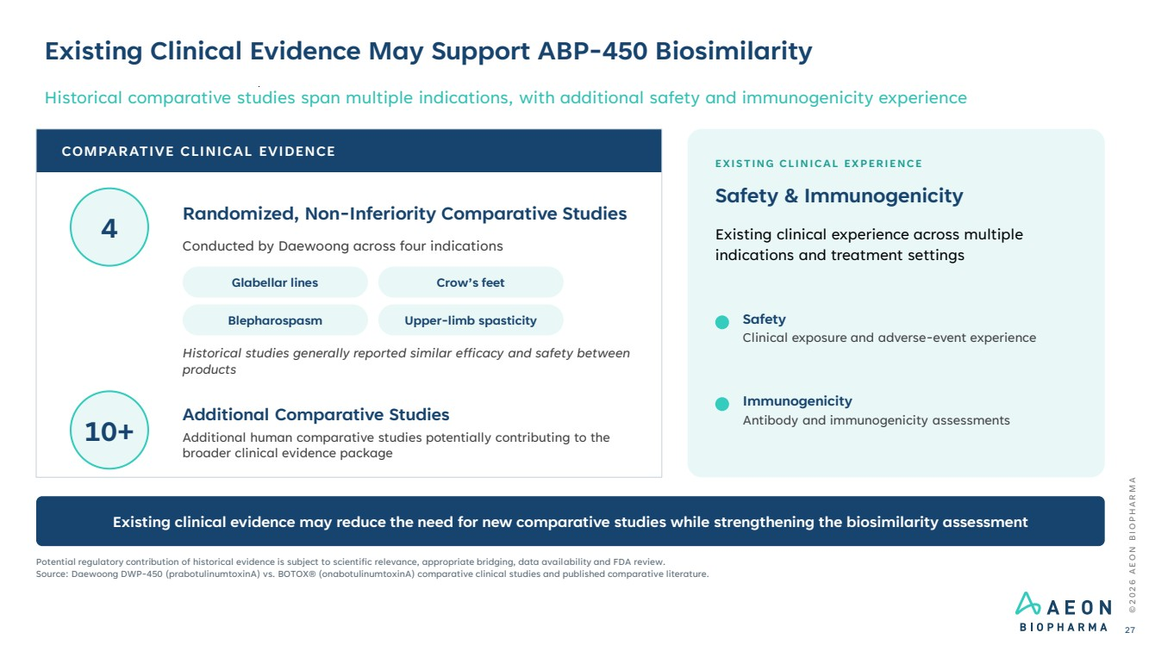 | Existing Clinical Evidence May Support ABP-450 Biosimilarity Historical comparative studies span multiple indications, with additional safety and immunogenicity experience © 2 0 2 6 A E O N B I O P H A R M A 27 COMPARATIVE CLINICAL EVIDENCE Randomized, Non-Inferiority Comparative Studies Conducted by Daewoong across four indications Glabellar lines Crow’s feet Blepharospasm Upper-limb spasticity Historical studies generally reported similar efficacy and safety between products Additional Comparative Studies Additional human comparative studies potentially contributing to the broader clinical evidence package EXISTING CLINICAL EXPERIENCE Safety & Immunogenicity Existing clinical experience across multiple indications and treatment settings Safety Clinical exposure and adverse-event experience Immunogenicity Antibody and immunogenicity assessments Existing clinical evidence may reduce the need for new comparative studies while strengthening the biosimilarity assessment Potential regulatory contribution of historical evidence is subject to scientific relevance, appropriate bridging, data availability and FDA review. Source: Daewoong DWP-450 (prabotulinumtoxinA) vs. BOTOX® (onabotulinumtoxinA) comparative clinical studies and published comparative literature. 4 10+
 | 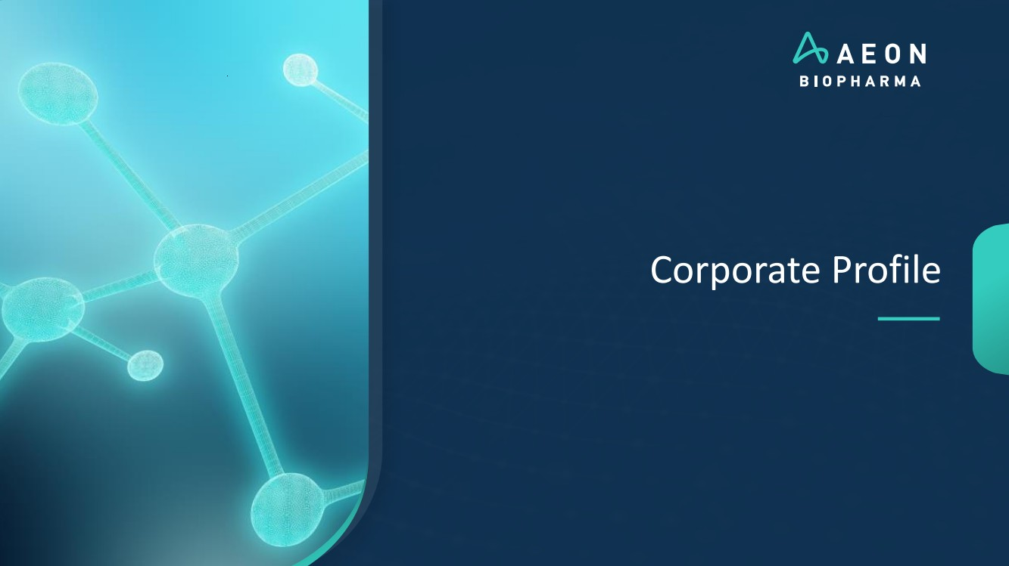 | Corporate Profile
 | 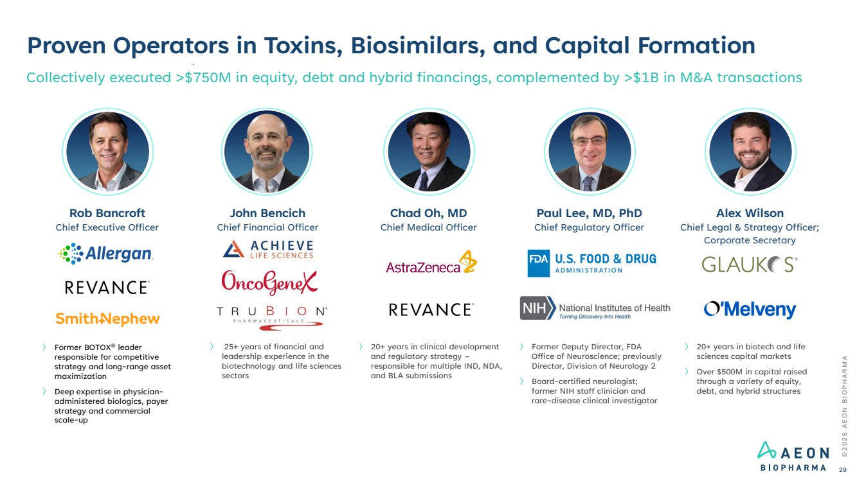 | Proven Operators in Toxins, Biosimilars, and Capital Formation Collectively executed >$750M in equity, debt and hybrid financings, complemented by >$1B in M&A transactions 〉 20+ years in biotech and life sciences capital markets 〉 Over $500M in capital raised through a variety of equity, debt, and hybrid structures Alex Wilson Chief Legal & Strategy Officer; Corporate Secretary 〉 Former BOTOX® leader responsible for competitive strategy and long-range asset maximization 〉 Deep expertise in physician-administered biologics, payer strategy and commercial scale-up Rob Bancroft Chief Executive Officer 〉 20+ years in clinical development and regulatory strategy – responsible for multiple IND, NDA, and BLA submissions Chad Oh, MD Chief Medical Officer 〉 Former Deputy Director, FDA Office of Neuroscience; previously Director, Division of Neurology 2 〉 Board-certified neurologist; former NIH staff clinician and rare-disease clinical investigator Paul Lee, MD, PhD Chief Regulatory Officer © 2 0 2 6 A E O N B I O P H A R M A 29 〉 25+ years of financial and leadership experience in the biotechnology and life sciences sectors John Bencich Chief Financial Officer
 | 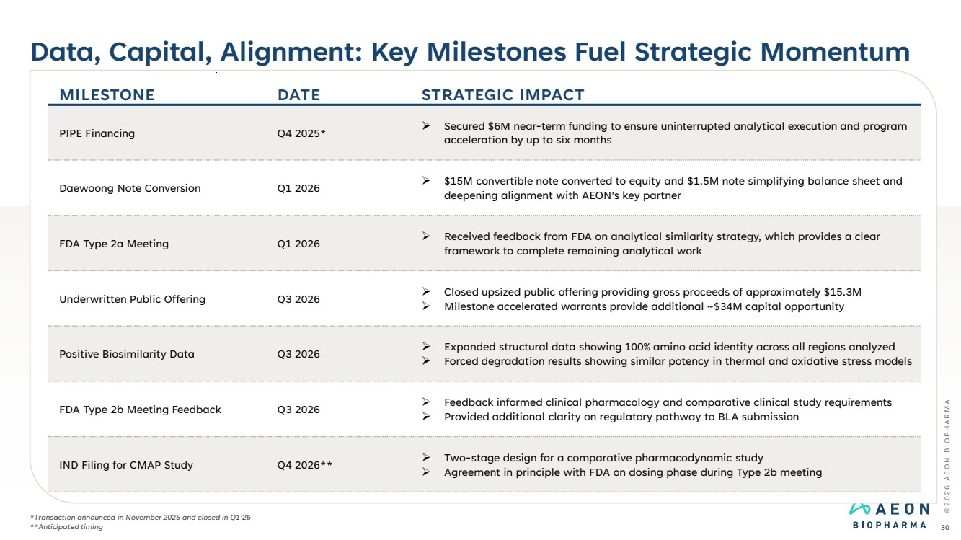 | Data, Capital, Alignment: Key Milestones Fuel Strategic Momentum © 2 0 2 6 A E O N B I O P H A R M A 30 MILESTONE DATE STRATEGIC IMPACT PIPE Financing Q4 2025* ➢ Secured $6M near-term funding to ensure uninterrupted analytical execution and program acceleration by up to six months Daewoong Note Conversion Q1 2026 ➢ $15M convertible note converted to equity and $1.5M note simplifying balance sheet and deepening alignment with AEON’s key partner FDA Type 2a Meeting Q1 2026 ➢ Received feedback from FDA on analytical similarity strategy, which provides a clear framework to complete remaining analytical work Underwritten Public Offering Q3 2026 ➢ Closed upsized public offering providing gross proceeds of approximately $15.3M ➢ Milestone accelerated warrants provide additional ~$34M capital opportunity Positive Biosimilarity Data Q3 2026 ➢ Expanded structural data showing 100% amino acid identity across all regions analyzed ➢ Forced degradation results showing similar potency in thermal and oxidative stress models FDA Type 2b Meeting Feedback Q3 2026 ➢ Feedback informed clinical pharmacology and comparative clinical study requirements ➢ Provided additional clarity on regulatory pathway to BLA submission IND Filing for CMAP Study Q4 2026** ➢ Two-stage design for a comparative pharmacodynamic study ➢ Agreement in principle with FDA on dosing phase during Type 2b meeting *Transaction announced in November 2025 and closed in Q1’26 **Anticipated timing
 | 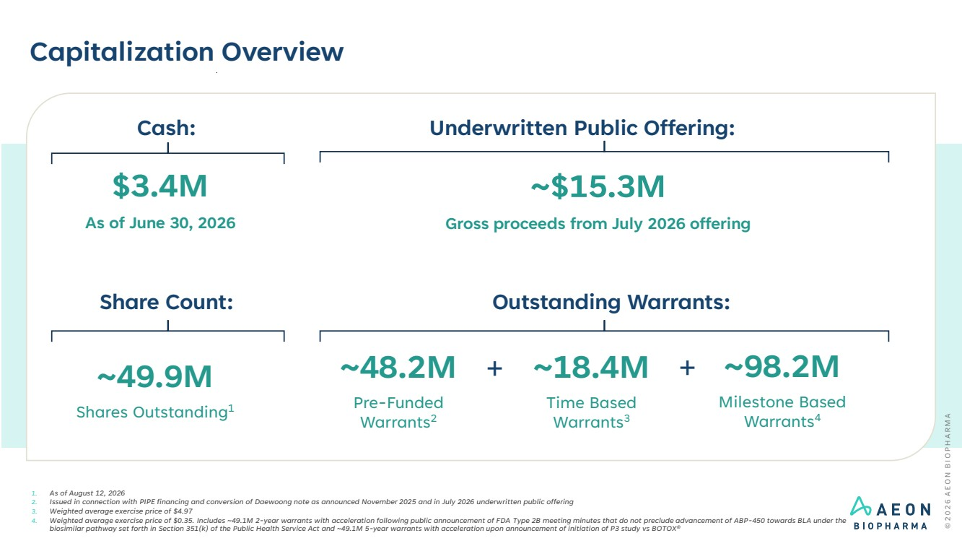 | Capitalization Overview 1. As of August 12, 2026 2. Issued in connection with PIPE financing and conversion of Daewoong note as announced November 2025 and in July 2026 underwritten public offering 3. Weighted average exercise price of $4.97 4. Weighted average exercise price of $0.35. Includes ~49.1M 2-year warrants with acceleration following public announcement of FDA Type 2B meeting minutes that do not preclude advancement of ABP-450 towards BLA under the biosimilar pathway set forth in Section 351(k) of the Public Health Service Act and ~49.1M 5-year warrants with acceleration upon announcement of initiation of P3 study vs BOTOX® Outstanding Warrants: ~49.9M Shares Outstanding1 ~18.4M Time Based Warrants3 ~98.2M Milestone Based Warrants4 + Share Count: ~48.2M Pre-Funded Warrants2 + Underwritten Public Offering: $3.4M As of June 30, 2026 Cash: ~$15.3M Gross proceeds from July 2026 offering
 | 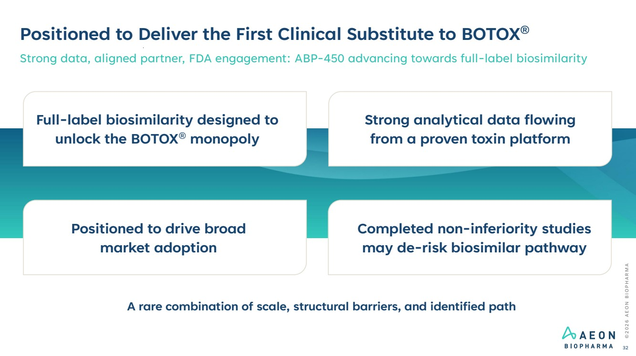 | Strong analytical data flowing from a proven toxin platform Completed non-inferiority studies may de-risk biosimilar pathway Positioned to drive broad market adoption Full-label biosimilarity designed to unlock the BOTOX® monopoly © 2 0 2 6 A E O N B I O P H A R M A 32 Positioned to Deliver the First Clinical Substitute to BOTOX® Strong data, aligned partner, FDA engagement: ABP-450 advancing towards full-label biosimilarity A rare combination of scale, structural barriers, and identified path
 | 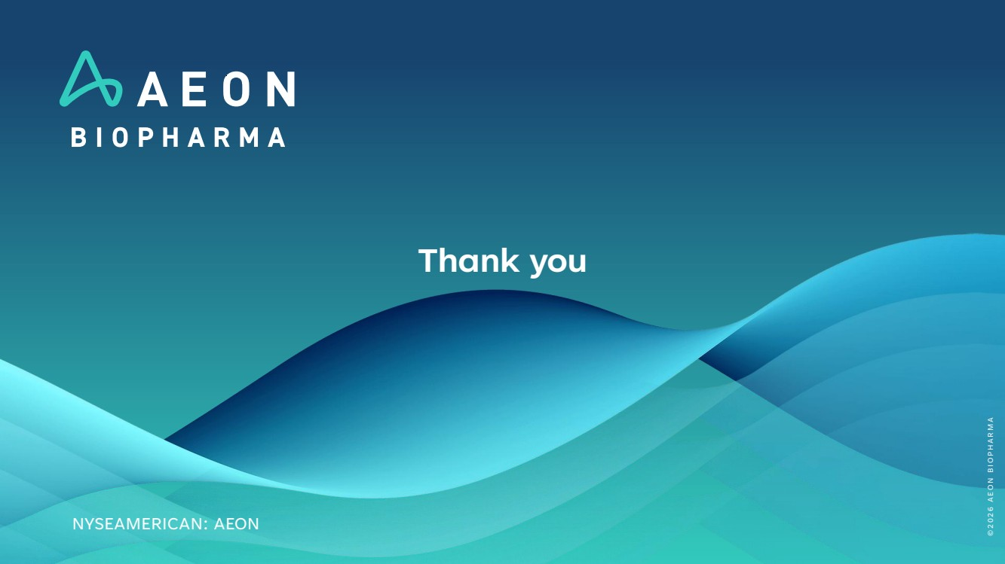 | Thank you NYSEAMERICAN: AEON © 2 0 2 6 A E O N B I O P H A R M A

