​
UNITED STATES
SECURITIES AND EXCHANGE COMMISSION
Washington, D.C. 20549
FORM 8-K
CURRENT REPORT
Pursuant to Section 13 or 15(d) of the
Securities Exchange Act of 1934
Date of Report (Date of earliest event reported): August 12, 2026
AEON Biopharma, Inc.
(Exact name of registrant as specified in its charter)
​

Delaware | ​ ​ ​ | 001-40021 | ​ ​ ​ | 85-3940478
(State or other jurisdiction  of incorporation) |  | (Commission  File Number) |  | (IRS Employer  Identification Number)
​
130 Vantis Dr.
Suite 170
Aliso Viejo, CA 92656
(Address of principal executive offices, including Zip Code)
Registrant’s telephone number, including area code: (949) 354-6499
Check the appropriate box below if the Form 8-K filing is intended to simultaneously satisfy the filing obligation of the registrant under any of the following provisions:
 | ☐ | Written communications pursuant to Rule 425 under the Securities Act (17 CFR 230.425)
 | ☐ | Soliciting material pursuant to Rule 14a-12 under the Exchange Act (17 CFR 240.14a-12)
 | ☐ | Pre-commencement communications pursuant to Rule 14d-2(b) under the Exchange Act (17 CFR 240.14d-2(b))
 | ☐ | Pre-commencement communications pursuant to Rule 13e-4(c) under the Exchange Act (17 CFR 240.13e-4(c))
Securities registered pursuant to Section 12(b) of the Act:
​

​ | ​ | ​ | ​ | ​
Title of each class | ​ ​ ​ | Trading Symbol | ​ ​ ​ | Name of each exchange on which registered
Class A Common Stock, $0.0001 par value per share | ​ | AEON | ​ | NYSE American
​
Indicate by check mark whether the registrant is an emerging growth company as defined in Rule 405 of the Securities Act of 1933 (§230.405 of this chapter) or Rule 12b-2 of the Securities Exchange Act of 1934 (§240.12b-2 of this chapter).
Emerging growth company ☒
If an emerging growth company, indicate by check mark if the registrant has elected not to use the extended transition period for complying with any new or revised financial accounting standards provided pursuant to Section 13(a) of the Exchange Act. ☐
​
​
​
​
​
​
Item 2.02. Results of Operations and Financial Condition.
On August 12, 2026, AEON Biopharma, Inc. (the “Company” or “AEON”) announced financial results for the second quarter ended June 30, 2026. The full text of the press release issued in connection with the announcement is furnished as Exhibit 99.1, to this Current Report on Form 8-K (this “Report”).
Item 7.01. Regulation FD Disclosure.
On August 12, 2026, AEON made available in the investor relations section of its website a presentation (the “Corporate Presentation”), a copy of which is furnished as Exhibit 99.2 to this Report and incorporated herein by reference.
The information from the Corporate Presentation may also be used by the management of the Company in future meetings regarding the Company. For important information about forward-looking statements in the Corporate Presentation, see the slide titled “Forward-Looking Statements” in Exhibit 99.2 attached hereto.
The information furnished pursuant to Items 2.02 and 7.01 of this Report (including Exhibit 99.1 and 99.2) shall not be deemed “filed” for purposes of Section 18 of the Securities Exchange Act of 1934, as amended (the “Exchange Act”) or otherwise subject to the liabilities of that section, nor shall it be deemed incorporated by reference in any filing under the Securities Act of 1933, as amended, or the Exchange Act, regardless of any general incorporation language in such filing, unless expressly incorporated by specific reference in such a filing.
Item 9.01. Financial Statement and Exhibits.
​
(d) Exhibits.
​
​
Exhibit No. |  |  |  |  |  |  | Description
​ |  | ​ |  |  |  |  | ​
99.1 |  |  |  |  |  |  | Press Release, dated August 12, 2026.
99.2 |  | ​ |  |  |  |  | Corporate Presentation, dated August 2026.
104 |  | ​ |  |  |  |  | Cover Page Interactive Data File (embedded within the Inline XBRL document)
​
​
​
SIGNATURE
Pursuant to the requirements of the Securities Exchange Act of 1934, the registrant has duly caused this report to be signed on its behalf by the undersigned hereunto duly authorized.
​
​ | ​ | ​
​ | AEON Biopharma, Inc.
Date: August 12, 2026 | By: | /s/ Robert Bancroft
​ | ​ | Robert Bancroft
​ | ​ | President and Chief Executive Officer  ​
​
​
​
Exhibit 99.1


PRESS RELEASE
AEON Biopharma Reports Second Quarter 2026 Financial Results and Provides Corporate Update
- Executed a $15.3 million financing with milestone warrants providing potential for an additional $34.0 million in gross proceeds, supporting continued advancement of ABP-450's development program -
- Upfront proceeds from financing provide cash runway into the first quarter of 2027 -
ALISO VIEJO, Calif., August 12, 2026 – AEON Biopharma, Inc. (“AEON” or the “Company”) (NYSE American: AEON), a biopharmaceutical company advancing ABP-450 as a biosimilar to BOTOX® (onabotulinumtoxinA) for therapeutic use to achieve full-label U.S. market entry, today reported its financial results for the second quarter ended June 30, 2026, and provided a corporate update.
“The second quarter marked continued progress in advancing ABP-450 through the analytical phase of our biosimilar development program while also strengthening the Company's financial position," commented Rob Bancroft, President and Chief Executive Officer of AEON. "As we enter the second half of 2026, our primary focus is obtaining FDA feedback on the next phase of development, including the clinical pharmacology and comparative clinical study requirements for ABP-450. With the successful completion of our recently oversubscribed public offering, AEON is well positioned to execute on our near-term regulatory and corporate objectives as we continue advancing our goal of bringing a biosimilar to BOTOX® to the therapeutic market."”
Second Quarter 2026 Highlights and Recent Developments
●Continued Advancement Toward BPD Type 2b Regulatory Feedback
oAEON held a successful Biosimilar Biological Product Development (BPD) Type 2a meeting with the U.S. Food and Drug Administration (FDA) during the first quarter of 2026. During the meeting, the Agency reviewed the Company's proposed analytical similarity strategy under the 351(k) biosimilar pathway and provided feedback supporting AEON's planned analytical development approach for ABP-450. Collectively, the FDA's feedback provided AEON with well-defined direction and a framework for the remaining analytical components of its biosimilar development program. The Agency also acknowledged the unique scientific challenges associated with characterizing the 900 kDa botulinum neurotoxin complex due to its large size and exceptional potency, while providing constructive feedback on the Company's proposed analytical assessment plan. The Company looks forward to feedback from its planned BPD Type 2b interaction with the FDA in the second half of 2026, which is expected to help inform the next phase of development for ABP-450, including clinical pharmacology and comparative clinical study requirements.
●Strengthened Balance Sheet through a $15.3 Million Financing with Milestone Warrants Providing Potential for an Additional $34.0 Million in Gross Proceeds
oIn July 2026, the Company completed an underwritten public offering that included net upfront proceeds of approximately $13.6 million, and up to an additional $34.0 million in potential gross proceeds upon the cash exercise in full of the milestone warrants issued in the offering. Upfront proceeds from the offering are expected to provide cash runway into the first quarter of 2027.
●NYSE American Compliance Restored
oOn August 3, 2026, the Company regained full compliance with NYSE American continued listing requirements, resolving previously identified deficiencies and maintaining its listing on the exchange.
​
‌

Exhibit 99.1

PRESS RELEASE
 | ● | Presented Data and Advanced Scientific Engagement Supporting Analytical Similarity to BOTOX®
 | o | In April 2026, the Company presented a poster at the 2026 American Academy of Neurology (AAN) Annual Meeting entitled “Establishing Primary Structure Comparability Between ABP-450 (prabotulinumtoxinA) and OnabotulinumtoxinA (Botox®) to Support Biosimilarity.” The poster expanded upon analytical data previously reported by the Company demonstrating identical primary amino acid sequence between ABP-450 and the reference product, based on 93.5%–99.3% peptide sequence coverage.
 | o | In June 2026, the Company presented an Abstract at the American Headache Society (AHS) Annual Meeting entitled “Establishing Structural and Functional Comparability Between ABP-450 and OnabotulinumtoxinA to Support Biosimilarity.”
Liquidity and Capital Resources
The Company reported cash and cash equivalents of $3.4 million as of June 30, 2026, which does not include approximately $13.6 million of net proceeds from the underwritten public offering that was completed in July 2026. Including those proceeds, cash and cash equivalents are expected to fund operations into the first quarter of 2027, supporting continued advancement of the ABP-450 program including ongoing analytical and regulatory activities.
ABP-450 Development Milestones & Scientific and/or Corporate Events
 | ● | Second half 2026: Receipt of additional FDA feedback expected to inform the next phase of the ABP-450 biosimilar development program, including clinical pharmacology and comparative clinical study requirements.
About the U.S. Biosimilar Pathway
Analytical similarity forms the scientific foundation of the 351(k) pathway and represents the most data-intensive phase of biosimilar development. When analytical comparability across critical quality attributes is robustly demonstrated, the FDA may reduce the scope of required clinical studies under its totality-of-the-evidence framework. Sponsors may also seek extrapolation to additional indications of the reference product when scientifically justified.
About AEON Biopharma
AEON Biopharma is a biopharmaceutical company pursuing full-label access to the U.S. therapeutic neurotoxin market via biosimilarity to BOTOX®. The U.S. therapeutic neurotoxin market exceeds $3.0 billion annually, representing a major opportunity for biosimilar entry. ABP-450 is the same botulinum toxin complex currently approved and marketed for cosmetic indications by Evolus, Inc. under the name Jeuveau®. ABP-450 is manufactured by Daewoong Pharmaceutical in a facility that has been authorized by the U.S. Food and Drug Administration, Health Canada, and European Medicines Agency for the manufacture of third-party botulinum toxin products. AEON has exclusive development and distribution rights for therapeutic indications of ABP-450 in the United States, Canada, the European Union, the United Kingdom, and certain other international territories. To learn more about AEON, visit www.aeonbiopharma.com.
Forward-Looking Statements
The foregoing material may contain “forward-looking statements” within the meaning of Section 27A of the Securities Act of 1933 and Section 21E of the Securities Exchange Act of 1934, each as amended. Forward-looking statements include all statements that do not relate solely to historical or current facts, including without limitation statements regarding the Company’s product development and business prospects, and can be identified by the use of words such as “may,” “will,” “expect,” “project,” “estimate,” “anticipate,” “plan,” “believe,” “potential,” “should,” “continue” or the negative versions of those words or other comparable words. Forward-looking statements are not guarantees of future actions or
​
‌

Exhibit 99.1

PRESS RELEASE
performance. These forward-looking statements are based on information currently available to the Company and its current plans or expectations and are subject to a number of risks and uncertainties that could significantly affect current plans. Should one or more of these risks or uncertainties materialize, or the underlying assumptions prove incorrect, actual results may differ significantly from those anticipated, believed, estimated, expected, intended, or planned. Although the Company believes that the expectations reflected in the forward-looking statements are reasonable, the Company cannot guarantee future results, performance, or achievements. Except as required by applicable law, including the securities laws of the United States, the Company does not intend to update any of the forward-looking statements to conform these statements to actual results.
Factors that may cause actual results to differ materially from current expectations include, but are not limited to: (i) AEON’s ability to continue to meet continued stock exchange listing standards; (ii) the Company’s ability to obtain additional and sufficient financing; (iii) the Company’s anticipated financial performance, including cash and cash equivalents; (iv) the Company’s plans regarding any interactions with the FDA; (v) the outcome of any regulatory interactions; and (vi) other risks and uncertainties set forth in the section entitled “Risk Factors” and “Cautionary Note Regarding Forward-Looking Statements” in the Company’s filings with the SEC, which are available on the SEC’s website at www.sec.gov.
Contacts
Investor Contact:
Hershel Berry
Blueprint Life Science Group
hberry@Bplifescience.com
Source: AEON Biopharma
​
​
‌

Exhibit 99.1

PRESS RELEASE
‌
​
AEON BIOPHARMA, INC.
CONDENSED CONSOLIDATED BALANCE SHEETS
(in thousands, except share data and par value amounts)
​
​ | ​ | ​ | ​ | ​ | ​ | ​ | ​
​ | ​ | June 30, |  | ​ | ​ | December 31,
​ | ​ | 2026 |  | ​ ​ ​ | ​ ​ ​ | 2025
​ | ​ | ​ |  | ​ | ​ | ​
ASSETS | ​ | ​ | ​ |  |  | ​ | ​
Current assets: | ​ | ​ | ​ |  |  | ​ | ​
Cash and cash equivalents | ​ | $ | 3,431 | ​ | ​ | $ | 3,006
Prepaid expenses and other current assets | ​ |  | 562 | ​ | ​ |  | 392
Total current assets | ​ |  | 3,993 | ​ | ​ |  | 3,398
Property and equipment, net | ​ |  | 123 | ​ | ​ |  | 162
Operating lease right-of-use asset | ​ |  | 931 | ​ | ​ |  | 1,052
Other assets | ​ |  | 863 | ​ | ​ |  | 948
Total assets | ​ | $ | 5,910 | ​ | ​ | $ | 5,560
LIABILITIES AND STOCKHOLDERS' DEFICIT | ​ |  | ​ | ​ | ​ |  | ​
Current liabilities: | ​ |  | ​ | ​ | ​ |  | ​
Accounts payable | ​ | $ | 2,697 | ​ | ​ | $ | 942
Accrued clinical trials expenses | ​ |  | 933 | ​ | ​ |  | 1,426
Accrued compensation | ​ |  | 1,897 | ​ | ​ |  | 2,872
Other accrued expenses | ​ |  | 1,815 | ​ | ​ |  | 1,657
Total current liabilities | ​ |  | 7,342 | ​ | ​ |  | 6,897
Convertible notes at fair value, including related party amount of $1,755 and $34,600 at June 30, 2026 and December 31, 2025, respectively | ​ |  | 1,755 | ​ | ​ |  | 34,600
Operating lease liability | ​ |  | 757 | ​ | ​ |  | 893
Derivative liability | ​ | ​ | — | ​ | ​ | ​ | 14,879
Warrant liabilities | ​ | ​ | 11,367 | ​ | ​ | ​ | 3,276
Contingent consideration liability | ​ | ​ | 27 | ​ | ​ | ​ | 42
Other liabilities | ​ |  | 23 | ​ | ​ |  | —
Total liabilities | ​ |  | 21,271 | ​ | ​ |  | 60,587
Commitments and contingencies | ​ |  | ​ | ​ | ​ |  | ​
Stockholders’ Deficit: | ​ |  | ​ | ​ | ​ |  | ​
Class A common stock, $0.0001 par value; 1,040,000,000 and 500,000,000 shares authorized at June 30, 2026 and December 31, 2025, and 26,307,211 and 12,105,902 shares issued and outstanding at June 30, 2026 and December 31, 2025, respectively | ​ |  | 10 | ​ | ​ |  | 9
Additional paid-in capital | ​ |  | 468,396 | ​ | ​ |  | 415,783
Accumulated deficit | ​ |  | (483,767) | ​ | ​ |  | (470,819)
Total stockholders' deficit | ​ |  | (15,361) | ​ | ​ |  | (55,027)
Total liabilities and stockholders' deficit | ​ | $ | 5,910 | ​ | ​ | $ | 5,560
​
​
​
​
​
​
‌

Exhibit 99.1

PRESS RELEASE
AEON BIOPHARMA, INC.
CONDENSED CONSOLIDATED STATEMENTS OF OPERATIONS AND COMPREHENSIVE (LOSS) INCOME
(in thousands, except share and per share data)
​
​ | ​ | ​ | ​ | ​ | ​ | ​ | ​ | ​ | ​ | ​ | ​ | ​ | ​
​ | ​ ​ ​ | Three Months Ended |  |  |  |  | ​ | Six Months Ended |  |  |  |  | ​
​ | ​ | June 30, |  |  |  |  | ​ | June 30, |  |  |  |  | ​
​ | ​ | 2026 |  | ​ ​ ​ | 2025 |  | ​ | 2026 |  | ​ ​ ​ | 2025 |  | ​
Operating expenses: |  | ​ | ​ |  | ​ | ​ | ​ | ​ | ​ | ​ | ​ | ​ | ​
Selling, general and administrative | ​ | $ | 2,991 | ​ | $ | 3,258 | ​ | $ | 6,893 | ​ | $ | 6,383 | ​
Research and development | ​ |  | 2,938 | ​ |  | 1,064 | ​ |  | 4,973 | ​ |  | 1,889
Change in fair value of contingent consideration | ​ |  | (10) | ​ |  | 16 | ​ |  | (15) | ​ |  | (3,472)
Total operating costs and expenses | ​ |  | 5,919 | ​ |  | 4,338 | ​ |  | 11,851 | ​ |  | 4,800
Loss from operations | ​ |  | (5,919) | ​ |  | (4,338) | ​ |  | (11,851) | ​ |  | (4,800)
Other (loss) income: | ​ |  | ​ | ​ |  | ​ | ​ |  | ​ | ​ |  | ​
Change in fair value of convertible notes | ​ |  | (213) | ​ |  | (1,854) | ​ |  | (8,940) | ​ |  | (3,485)
Change in fair value of warrants | ​ |  | 4,941 | ​ |  | (542) | ​ |  | 9,597 | ​ |  | 86,187
Loss on issuance of warrants | ​ | ​ | — | ​ | ​ | — | ​ | ​ | — | ​ |  | (75,644)
Loss on extinguishment of debt | ​ | ​ | — | ​ | ​ | — | ​ | ​ | (76) | ​ |  | —
Loss on derivative liability | ​ | ​ | — | ​ | ​ | — | ​ | ​ | (1,743) | ​ | ​ | — | ​
Other income, net | ​ |  | 36 | ​ |  | 92 | ​ |  | 65 | ​ |  | 195
Total other loss, net | ​ |  | 4,764 | ​ |  | (2,304) | ​ |  | (1,097) | ​ |  | 7,253
(Loss) income before taxes | ​ |  | (1,155) | ​ |  | (6,642) | ​ |  | (12,948) | ​ |  | 2,453
Income taxes | ​ |  | — | ​ |  | — | ​ |  | — | ​ |  | —
Net (loss) income | ​ | $ | (1,155) | ​ | $ | (6,642) | ​ | $ | (12,948) | ​ | $ | 2,453 | ​
Basic net (loss) income per share | ​ | $ | (0.02) | ​ | $ | (0.60) | ​ | $ | (0.28) | ​ | $ | 0.32 | ​
Diluted net (loss) income per share | ​ | $ | (0.02) | ​ | $ | (0.60) | ​ | $ | (0.28) | ​ | $ | 0.31 | ​
Weighted average shares of common stock outstanding used to compute basic net (loss) income per share | ​ | ​ | 50,530,946 | ​ | ​ | 11,090,809 | ​ | ​ | 45,599,911 | ​ | ​ | 7,557,472 | ​
Weighted average shares of common stock outstanding used to compute diluted net (loss) income per share | ​ |  | 50,530,946 | ​ |  | 11,090,809 | ​ |  | 45,599,911 | ​ |  | 7,848,566
​
​
​
The accompanying condensed consolidated financial statements have been prepared in accordance with generally accepted accounting principles in the United States of America (“U.S. GAAP”). The condensed consolidated financial statements include the accounts of the Company and its controlled subsidiaries.
# # #
​
‌

Exhibit 99.2
 | 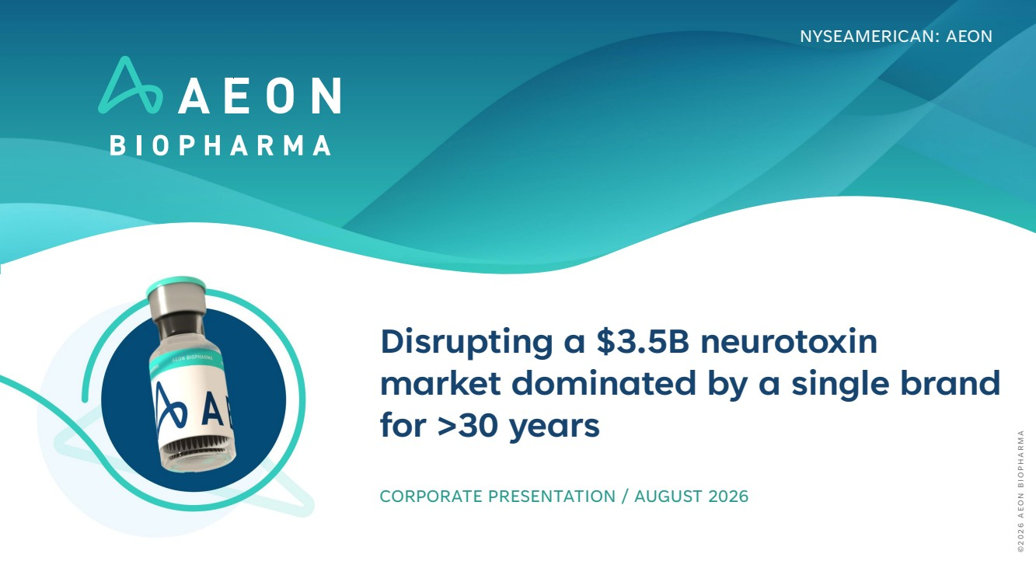 | Disrupting a $3.5B neurotoxin market dominated by a single brand for >30 years CORPORATE PRESENTATION / AUGUST 2026 NYSEAMERICAN: AEON ©2026 AEON BIOPHARMA
 | 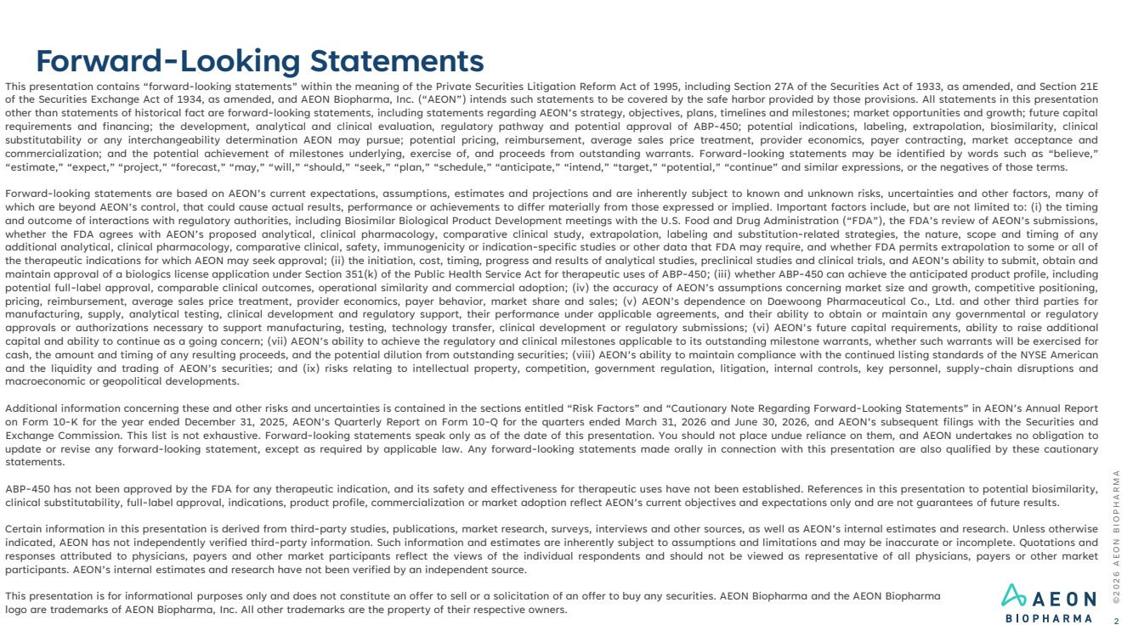 | This presentation contains “forward-looking statements” within the meaning of the Private Securities Litigation Reform Act of 1995, including Section 27A of the Securities Act of 1933, as amended, and Section 21E of the Securities Exchange Act of 1934, as amended, and AEON Biopharma, Inc. (“AEON”) intends such statements to be covered by the safe harbor provided by those provisions. All statements in this presentation other than statements of historical fact are forward-looking statements, including statements regarding AEON’s strategy, objectives, plans, timelines and milestones; market opportunities and growth; future capital requirements and financing; the development, analytical and clinical evaluation, regulatory pathway and potential approval of ABP-450; potential indications, labeling, extrapolation, biosimilarity, clinical substitutability or any interchangeability determination AEON may pursue; potential pricing, reimbursement, average sales price treatment, provider economics, payer contracting, market acceptance and commercialization; and the potential achievement of milestones underlying, exercise of, and proceeds from outstanding warrants. Forward-looking statements may be identified by words such as “believe,” “estimate,” “expect,” “project,” “forecast,” “may,” “will,” “should,” “seek,” “plan,” “schedule,” “anticipate,” “intend,” “target,” “potential,” “continue” and similar expressions, or the negatives of those terms. Forward-looking statements are based on AEON’s current expectations, assumptions, estimates and projections and are inherently subject to known and unknown risks, uncertainties and other factors, many of which are beyond AEON’s control, that could cause actual results, performance or achievements to differ materially from those expressed or implied. Important factors include, but are not limited to: (i) the timing and outcome of interactions with regulatory authorities, including Biosimilar Biological Product Development meetings with the U.S. Food and Drug Administration (“FDA”), the FDA’s review of AEON’s submissions, whether the FDA agrees with AEON’s proposed analytical, clinical pharmacology, comparative clinical study, extrapolation, labeling and substitution-related strategies, the nature, scope and timing of any additional analytical, clinical pharmacology, comparative clinical, safety, immunogenicity or indication-specific studies or other data that FDA may require, and whether FDA permits extrapolation to some or all of the therapeutic indications for which AEON may seek approval; (ii) the initiation, cost, timing, progress and results of analytical studies, preclinical studies and clinical trials, and AEON’s ability to submit, obtain and maintain approval of a biologics license application under Section 351(k) of the Public Health Service Act for therapeutic uses of ABP-450; (iii) whether ABP-450 can achieve the anticipated product profile, including potential full-label approval, comparable clinical outcomes, operational similarity and commercial adoption; (iv) the accuracy of AEON’s assumptions concerning market size and growth, competitive positioning, pricing, reimbursement, average sales price treatment, provider economics, payer behavior, market share and sales; (v) AEON’s dependence on Daewoong Pharmaceutical Co., Ltd. and other third parties for manufacturing, supply, analytical testing, clinical development and regulatory support, their performance under applicable agreements, and their ability to obtain or maintain any governmental or regulatory approvals or authorizations necessary to support manufacturing, testing, technology transfer, clinical development or regulatory submissions; (vi) AEON’s future capital requirements, ability to raise additional capital and ability to continue as a going concern; (vii) AEON’s ability to achieve the regulatory and clinical milestones applicable to its outstanding milestone warrants, whether such warrants will be exercised for cash, the amount and timing of any resulting proceeds, and the potential dilution from outstanding securities; (viii) AEON’s ability to maintain compliance with the continued listing standards of the NYSE American and the liquidity and trading of AEON’s securities; and (ix) risks relating to intellectual property, competition, government regulation, litigation, internal controls, key personnel, supply-chain disruptions and macroeconomic or geopolitical developments. Additional information concerning these and other risks and uncertainties is contained in the sections entitled “Risk Factors” and “Cautionary Note Regarding Forward-Looking Statements” in AEON’s Annual Report on Form 10-K for the year ended December 31, 2025, AEON’s Quarterly Report on Form 10-Q for the quarters ended March 31, 2026 and June 30, 2026, and AEON’s subsequent filings with the Securities and Exchange Commission. This list is not exhaustive. Forward-looking statements speak only as of the date of this presentation. You should not place undue reliance on them, and AEON undertakes no obligation to update or revise any forward-looking statement, except as required by applicable law. Any forward-looking statements made orally in connection with this presentation are also qualified by these cautionary statements. ABP-450 has not been approved by the FDA for any therapeutic indication, and its safety and effectiveness for therapeutic uses have not been established. References in this presentation to potential biosimilarity, clinical substitutability, full-label approval, indications, product profile, commercialization or market adoption reflect AEON’s current objectives and expectations only and are not guarantees of future results. Certain information in this presentation is derived from third-party studies, publications, market research, surveys, interviews and other sources, as well as AEON’s internal estimates and research. Unless otherwise indicated, AEON has not independently verified third-party information. Such information and estimates are inherently subject to assumptions and limitations and may be inaccurate or incomplete. Quotations and responses attributed to physicians, payers and other market participants reflect the views of the individual respondents and should not be viewed as representative of all physicians, payers or other market participants. AEON’s internal estimates and research have not been verified by an independent source. This presentation is for informational purposes only and does not constitute an offer to sell or a solicitation of an offer to buy any securities. AEON Biopharma and the AEON Biopharma logo are trademarks of AEON Biopharma, Inc. All other trademarks are the property of their respective owners. Forward-Looking Statements ©2026 AEON BIOPHARMA 2
 | 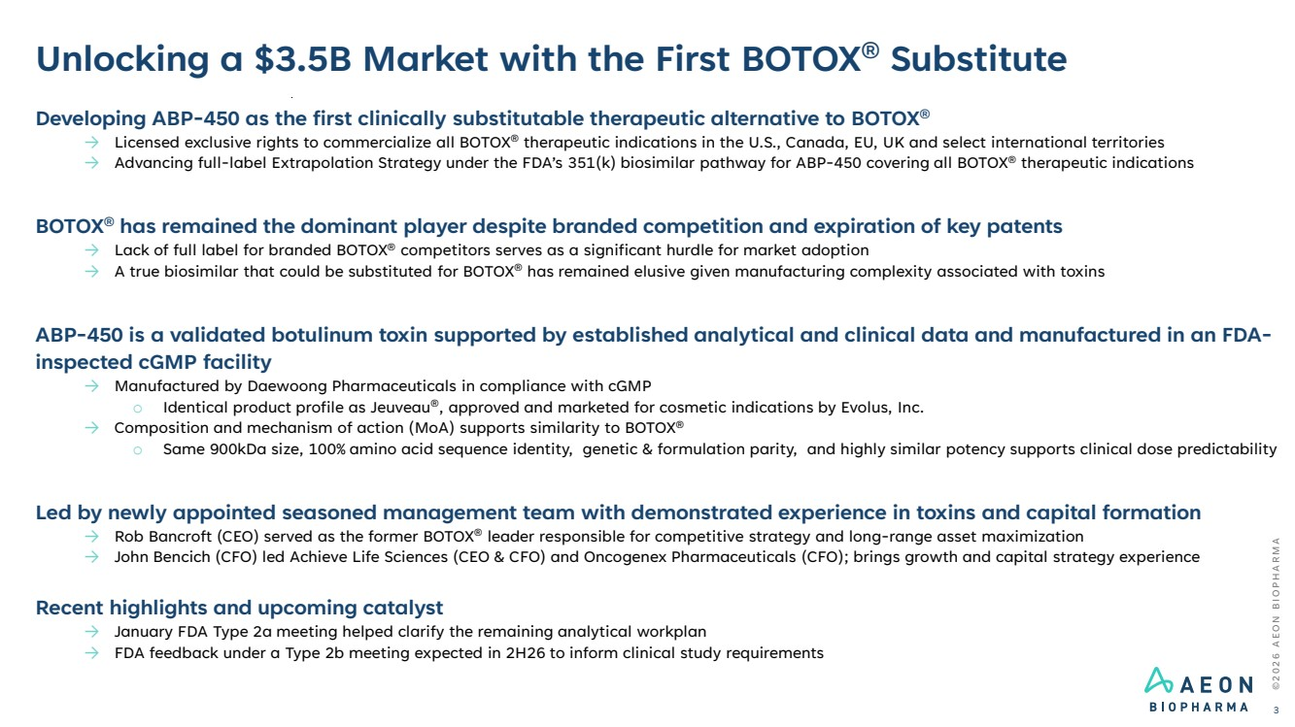 | ©2026 AEON BIOPHARMA Unlocking a $3.5B Market with the First BOTOX® Substitute 3 Developing ABP-450 as the first clinically substitutable therapeutic alternative to BOTOX® → Licensed exclusive rights to commercialize all BOTOX® therapeutic indications in the U.S., Canada, EU, UK and select international territories → Advancing full-label Extrapolation Strategy under the FDA’s 351(k) biosimilar pathway for ABP-450 covering all BOTOX® therapeutic indications BOTOX® has remained the dominant player despite branded competition and expiration of key patents → Lack of full label for branded BOTOX® competitors serves as a significant hurdle for market adoption → A true biosimilar that could be substituted for BOTOX® has remained elusive given manufacturing complexity associated with toxins ABP-450 is a validated botulinum toxin supported by established analytical and clinical data and manufactured in an FDA-inspected cGMP facility → Manufactured by Daewoong Pharmaceuticals in compliance with cGMP o Identical product profile as Jeuveau®, approved and marketed for cosmetic indications by Evolus, Inc. → Composition and mechanism of action (MoA) supports similarity to BOTOX® o Same 900kDa size, 100% amino acid sequence identity, genetic & formulation parity, and highly similar potency supports clinical dose predictability Led by newly appointed seasoned management team with demonstrated experience in toxins and capital formation → Rob Bancroft (CEO) served as the former BOTOX® leader responsible for competitive strategy and long-range asset maximization → John Bencich (CFO) led Achieve Life Sciences (CEO & CFO) and Oncogenex Pharmaceuticals (CFO); brings growth and capital strategy experience Recent highlights and upcoming catalyst → January FDA Type 2a meeting helped clarify the remaining analytical workplan → FDA feedback under a Type 2b meeting expected in 2H26 to inform clinical study requirements
 | 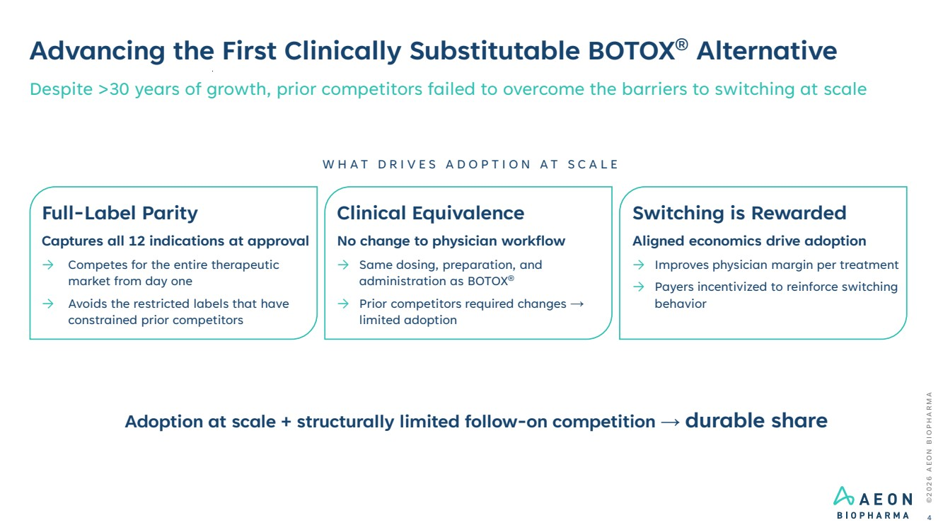 | ©2026 AEON BIOPHARMA Advancing the First Clinically Substitutable BOTOX® Alternative 4 Despite >30 years of growth, prior competitors failed to overcome the barriers to switching at scale Full-Label Parity Captures all 12 indications at approval → Competes for the entire therapeutic market from day one → Avoids the restricted labels that have constrained prior competitors Clinical Equivalence No change to physician workflow → Same dosing, preparation, and administration as BOTOX® → Prior competitors required changes → limited adoption Switching is Rewarded Aligned economics drive adoption → Improves physician margin per treatment → Payers incentivized to reinforce switching behavior WHAT DRIVES ADOPTION AT SCALE Adoption at scale + structurally limited follow-on competition → durable share
 | 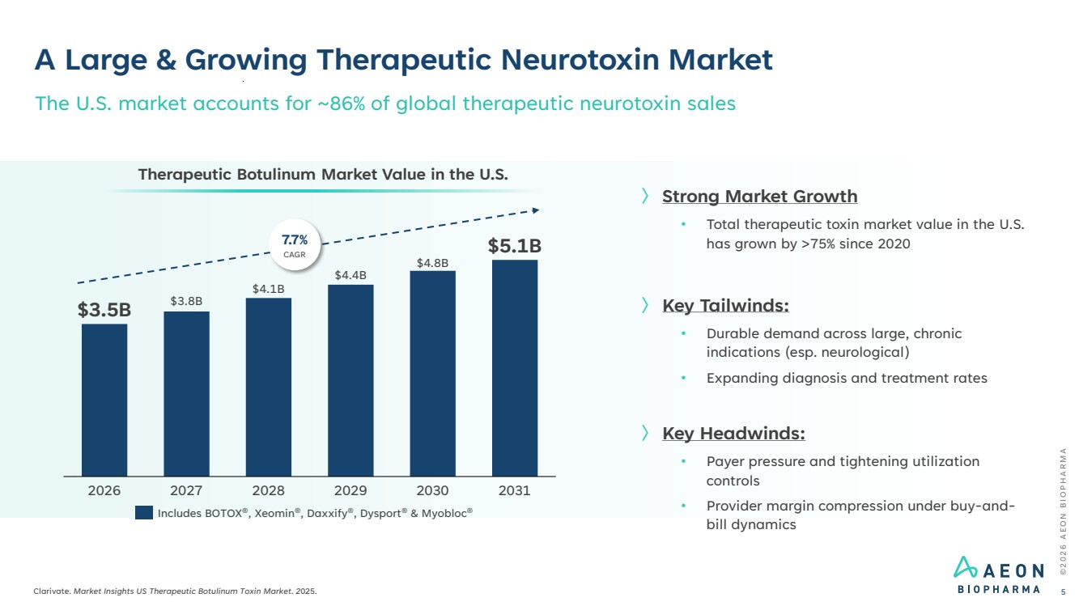 | ©2026 AEON BIOPHARMA Clarivate. Market Insights US Therapeutic Botulinum Toxin Market. 2025. 5 The U.S. market accounts for ~86% of global therapeutic neurotoxin sales 2026 2027 2028 2029 2030 2031 $3.5B $3.8B $4.1B $4.4B $4.8B $5.1B Therapeutic Botulinum Market Value in the U.S. 7.7% CAGR Includes BOTOX®, Xeomin®, Daxxify®, Dysport® & Myobloc® 〉 Strong Market Growth • Total therapeutic toxin market value in the U.S. has grown by >75% since 2020 〉 Key Tailwinds: • Durable demand across large, chronic indications (esp. neurological) • Expanding diagnosis and treatment rates 〉 Key Headwinds: • Payer pressure and tightening utilization controls • Provider margin compression under buy-and-bill dynamics A Large & Growing Therapeutic Neurotoxin Market
 | 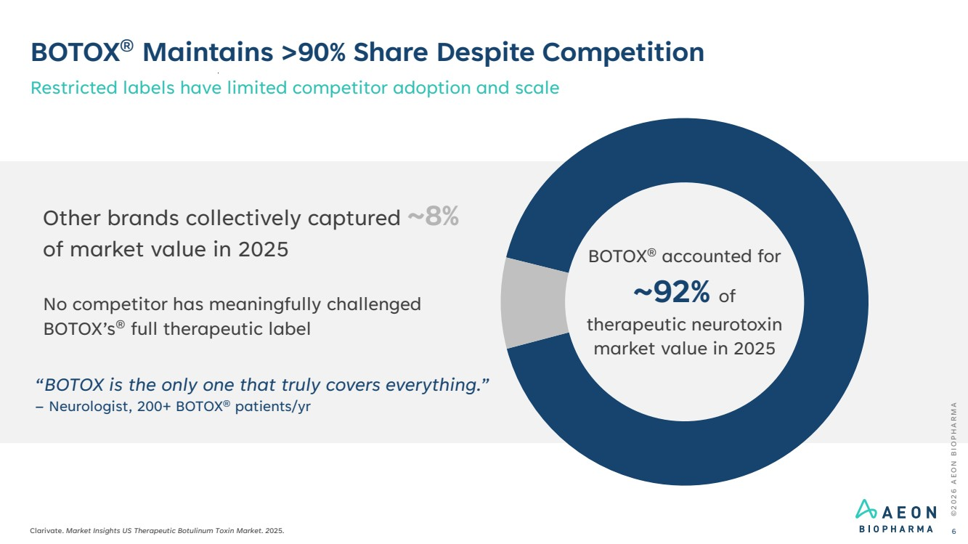 | BOTOX® Maintains >90% Share Despite Competition Restricted labels have limited competitor adoption and scale ©2026 AEON BIOPHARMA Clarivate. Market Insights US Therapeutic Botulinum Toxin Market. 2025. 6 Other brands collectively captured ~8% of market value in 2025 No competitor has meaningfully challenged BOTOX’s® full therapeutic label BOTOX® accounted for ~92% of therapeutic neurotoxin market value in 2025 “BOTOX is the only one that truly covers everything.” – Neurologist, 200+ BOTOX® patients/yr
 | 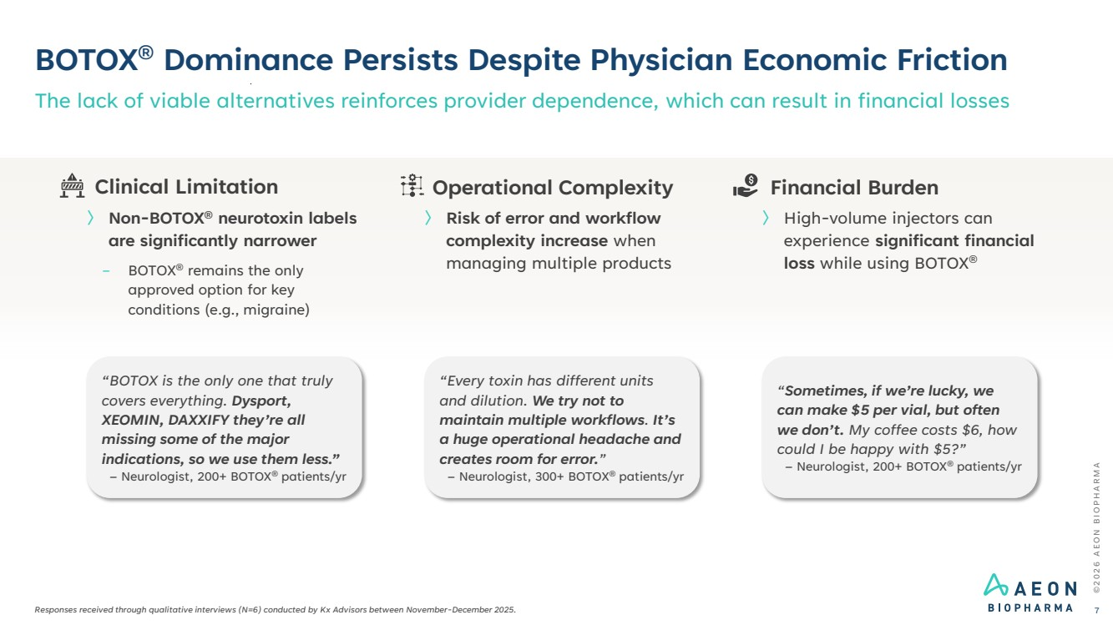 | ©2026 AEON BIOPHARMA BOTOX® Dominance Persists Despite Physician Economic Friction Responses received through qualitative interviews (N=6) conducted by Kx Advisors between November-December 2025. The lack of viable alternatives reinforces provider dependence, which can result in financial losses 7 “Sometimes, if we’re lucky, we can make $5 per vial, but often we don’t. My coffee costs $6, how could I be happy with $5?” – Neurologist, 200+ BOTOX® patients/yr “Every toxin has different units and dilution. We try not to maintain multiple workflows. It’s a huge operational headache and creates room for error.” – Neurologist, 300+ BOTOX® patients/yr “BOTOX is the only one that truly covers everything. Dysport, XEOMIN, DAXXIFY they’re all missing some of the major indications, so we use them less.” – Neurologist, 200+ BOTOX® patients/yr Financial Burden 〉 High-volume injectors can experience significant financial loss while using BOTOX® Operational Complexity 〉 Risk of error and workflow complexity increase when managing multiple products Clinical Limitation 〉 Non-BOTOX® neurotoxin labels are significantly narrower − BOTOX® remains the only approved option for key conditions (e.g., migraine)
 | 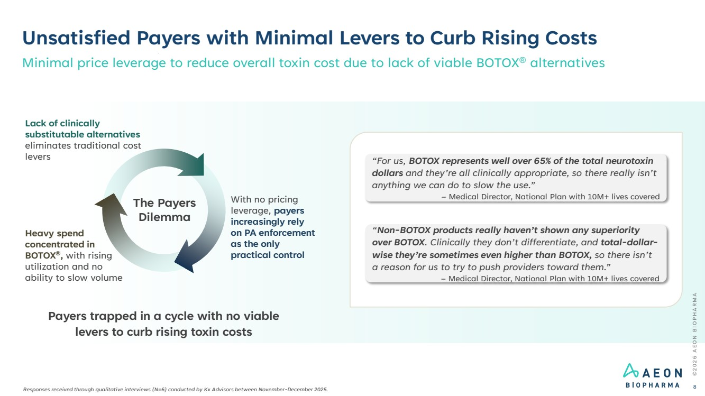 | Heavy spend concentrated in BOTOX®, with rising utilization and no ability to slow volume The Payers Dilemma Unsatisfied Payers with Minimal Levers to Curb Rising Costs ©2026 AEON BIOPHARMA 8 Payers trapped in a cycle with no viable levers to curb rising toxin costs “For us, BOTOX represents well over 65% of the total neurotoxin dollars and they’re all clinically appropriate, so there really isn’t anything we can do to slow the use.” – Medical Director, National Plan with 10M+ lives covered “Non-BOTOX products really haven’t shown any superiority over BOTOX. Clinically they don’t differentiate, and total-dollar-wise they’re sometimes even higher than BOTOX, so there isn’t a reason for us to try to push providers toward them.” – Medical Director, National Plan with 10M+ lives covered Minimal price leverage to reduce overall toxin cost due to lack of viable BOTOX® alternatives Lack of clinically substitutable alternatives eliminates traditional cost levers With no pricing leverage, payers increasingly rely on PA enforcement as the only practical control Responses received through qualitative interviews (N=6) conducted by Kx Advisors between November-December 2025.
 | 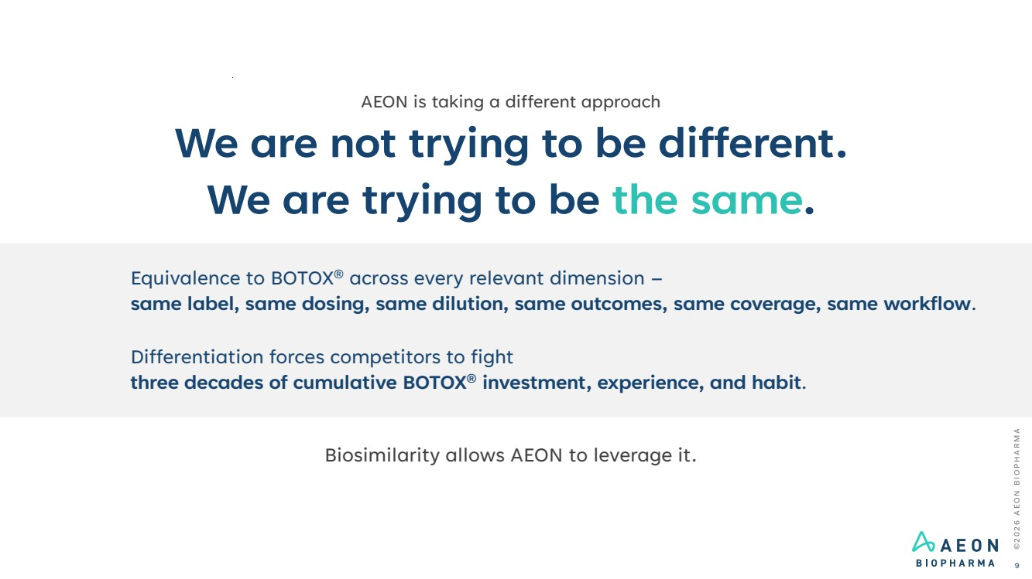 | ©2026 AEON BIOPHARMA 9 AEON is taking a different approach We are not trying to be different. We are trying to be the same. Equivalence to BOTOX® across every relevant dimension – same label, same dosing, same dilution, same outcomes, same coverage, same workflow. Differentiation forces competitors to fight three decades of cumulative BOTOX® investment, experience, and habit. Biosimilarity allows AEON to leverage it.
 | 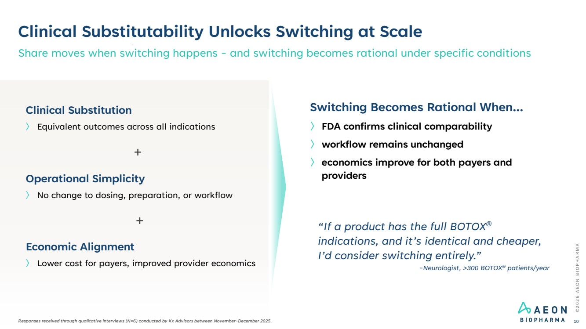 | Clinical Substitutability Unlocks Switching at Scale Share moves when switching happens - and switching becomes rational under specific conditions ©2026 AEON BIOPHARMA 10 〉 Lower cost for payers, improved provider economics Economic Alignment 〉 No change to dosing, preparation, or workflow Operational Simplicity 〉 Equivalent outcomes across all indications Clinical Substitution Switching Becomes Rational When... 〉 FDA confirms clinical comparability 〉 workflow remains unchanged 〉 economics improve for both payers and providers + + “If a product has the full BOTOX® indications, and it’s identical and cheaper, I’d consider switching entirely.” -Neurologist, >300 BOTOX® patients/year Responses received through qualitative interviews (N=6) conducted by Kx Advisors between November-December 2025.
 | 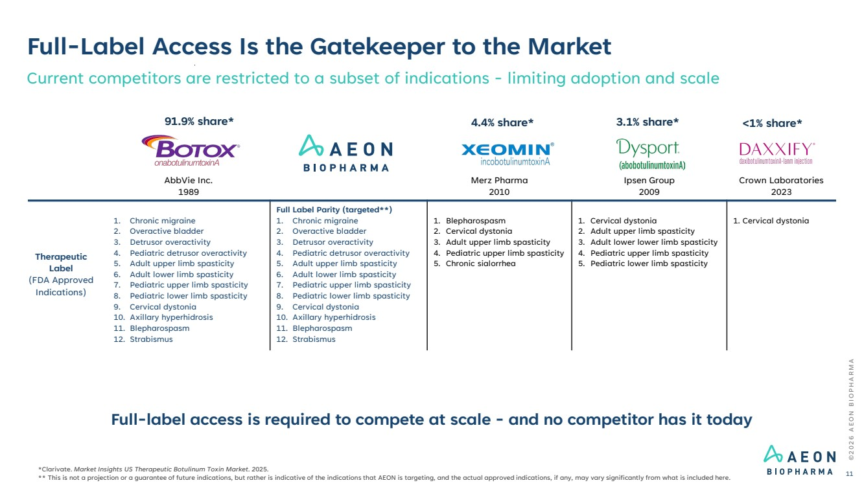 | AbbVie Inc. 1989 Merz Pharma 2010 Ipsen Group 2009 Crown Laboratories 2023 Therapeutic Label (FDA Approved Indications) 1. Chronic migraine 2. Overactive bladder 3. Detrusor overactivity 4. Pediatric detrusor overactivity 5. Adult upper limb spasticity 6. Adult lower limb spasticity 7. Pediatric upper limb spasticity 8. Pediatric lower limb spasticity 9. Cervical dystonia 10. Axillary hyperhidrosis 11. Blepharospasm 12. Strabismus Full Label Parity (targeted**) 1. Chronic migraine 2. Overactive bladder 3. Detrusor overactivity 4. Pediatric detrusor overactivity 5. Adult upper limb spasticity 6. Adult lower limb spasticity 7. Pediatric upper limb spasticity 8. Pediatric lower limb spasticity 9. Cervical dystonia 10. Axillary hyperhidrosis 11. Blepharospasm 12. Strabismus 1. Blepharospasm 2. Cervical dystonia 3. Adult upper limb spasticity 4. Pediatric upper limb spasticity 5. Chronic sialorrhea 1. Cervical dystonia 2. Adult upper limb spasticity 3. Adult lower lower limb spasticity 4. Pediatric upper limb spasticity 5. Pediatric lower limb spasticity 1. Cervical dystonia Full-Label Access Is the Gatekeeper to the Market Current competitors are restricted to a subset of indications - limiting adoption and scale Full-label access is required to compete at scale - and no competitor has it today ©2026 AEON BIOPHARMA 11 *Clarivate. Market Insights US Therapeutic Botulinum Toxin Market. 2025. ** This is not a projection or a guarantee of future indications, but rather is indicative of the indications that AEON is targeting, and the actual approved indications, if any, may vary significantly from what is included here. 91.9% share* 4.4% share* 3.1% share* <1% share*
 | 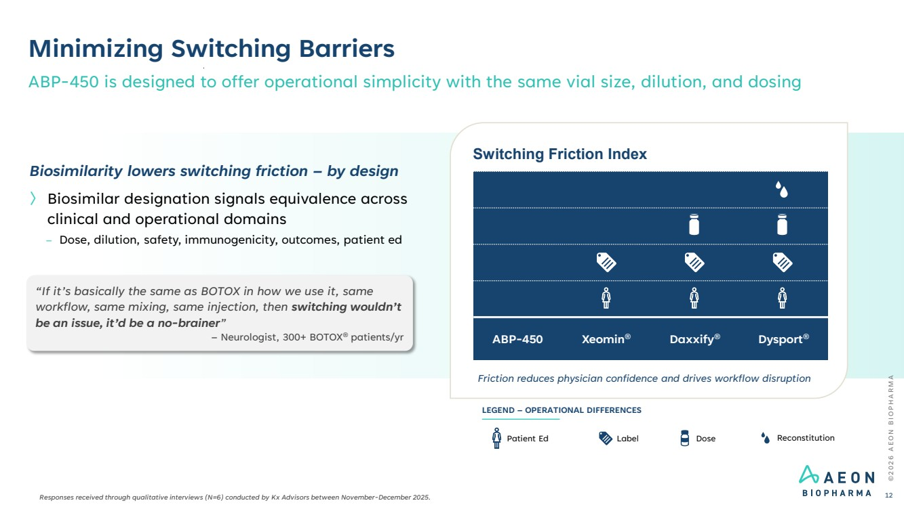 | ©2026 AEON BIOPHARMA Minimizing Switching Barriers ABP-450 is designed to offer operational simplicity with the same vial size, dilution, and dosing 12 Switching Friction Index Friction reduces physician confidence and drives workflow disruption ABP-450 Xeomin® Daxxify® Dysport® Label Dose Reconstitution LEGEND – OPERATIONAL DIFFERENCES Patient Ed Biosimilarity lowers switching friction – by design 〉 Biosimilar designation signals equivalence across clinical and operational domains – Dose, dilution, safety, immunogenicity, outcomes, patient ed “If it’s basically the same as BOTOX in how we use it, same workflow, same mixing, same injection, then switching wouldn’t be an issue, it’d be a no-brainer” – Neurologist, 300+ BOTOX® patients/yr Responses received through qualitative interviews (N=6) conducted by Kx Advisors between November-December 2025.
 | 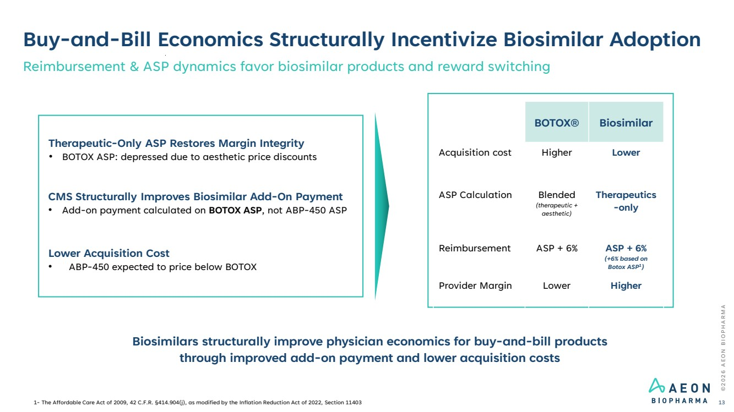 | Buy-and-Bill Economics Structurally Incentivize Biosimilar Adoption Reimbursement & ASP dynamics favor biosimilar products and reward switching ©2026 AEON BIOPHARMA 13 Biosimilars structurally improve physician economics for buy-and-bill products through improved add-on payment and lower acquisition costs Therapeutic-Only ASP Restores Margin Integrity • BOTOX ASP: depressed due to aesthetic price discounts CMS Structurally Improves Biosimilar Add-On Payment • Add-on payment calculated on BOTOX ASP, not ABP-450 ASP Lower Acquisition Cost • ABP-450 expected to price below BOTOX BOTOX® Biosimilar Acquisition cost Higher Lower ASP Calculation Blended (therapeutic + aesthetic) Therapeutics -only Reimbursement ASP + 6% ASP + 6% (+6% based on Botox ASP1) Provider Margin Lower Higher 1- The Affordable Care Act of 2009, 42 C.F.R. §414.904(j), as modified by the Inflation Reduction Act of 2022, Section 11403
 | 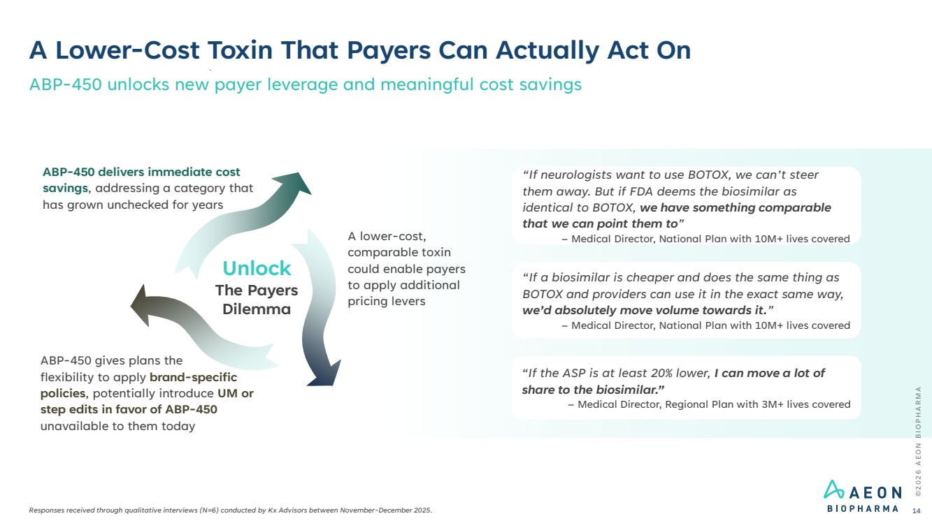 | ©2026 AEON BIOPHARMA A Lower-Cost Toxin That Payers Can Actually Act On Responses received through qualitative interviews (N=6) conducted by Kx Advisors between November-December 2025. ABP-450 unlocks new payer leverage and meaningful cost savings 14 “If neurologists want to use BOTOX, we can’t steer them away. But if FDA deems the biosimilar as identical to BOTOX, we have something comparable that we can point them to” – Medical Director, National Plan with 10M+ lives covered “If a biosimilar is cheaper and does the same thing as BOTOX and providers can use it in the exact same way, we’d absolutely move volume towards it.” – Medical Director, National Plan with 10M+ lives covered “If the ASP is at least 20% lower, I can move a lot of share to the biosimilar.” – Medical Director, Regional Plan with 3M+ lives covered ABP-450 gives plans the flexibility to apply brand-specific policies, potentially introduce UM or step edits in favor of ABP-450 unavailable to them today A lower-cost, comparable toxin could enable payers to apply additional pricing levers ABP-450 delivers immediate cost savings, addressing a category that has grown unchecked for years Unlock The Payers Dilemma
 | 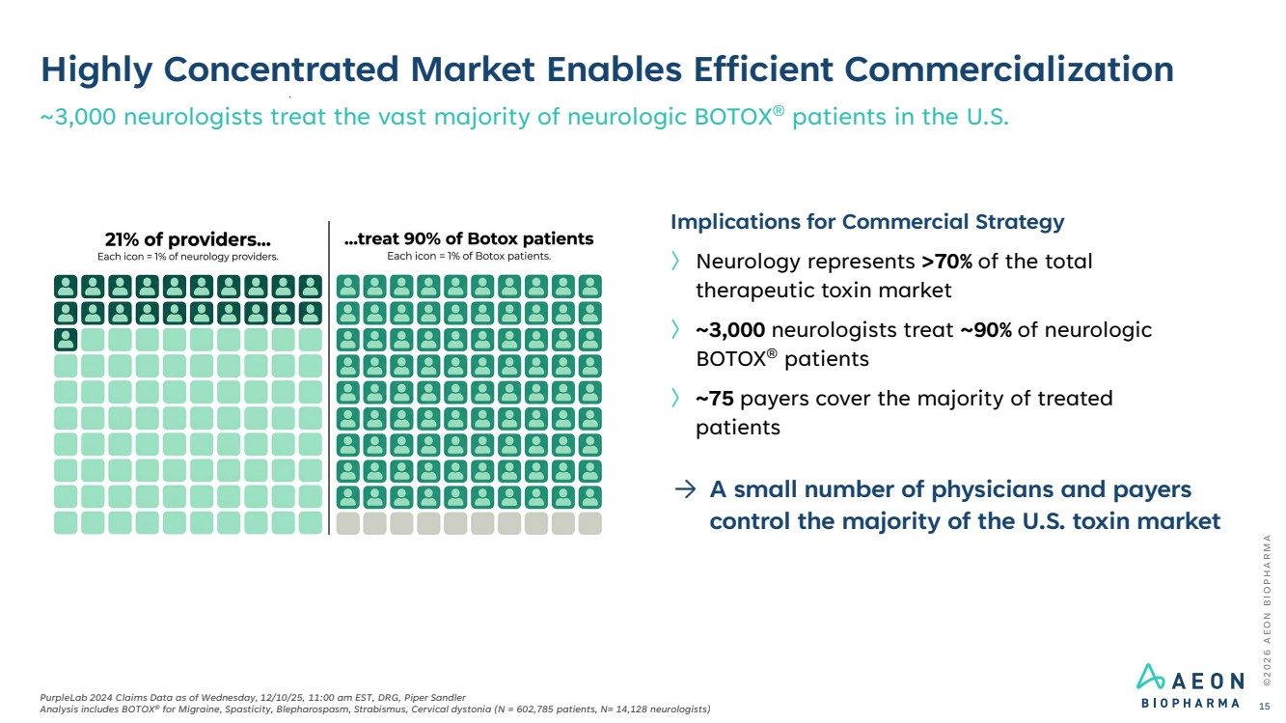 | Highly Concentrated Market Enables Efficient Commercialization ~3,000 neurologists treat the vast majority of neurologic BOTOX® patients in the U.S. ©2026 AEON BIOPHARMA PurpleLab 2024 Claims Data as of Wednesday, 12/10/25, 11:00 am EST, DRG, Piper Sandler Analysis includes BOTOX® for Migraine, Spasticity, Blepharospasm, Strabismus, Cervical dystonia (N = 602,785 patients, N= 14,128 neurologists) 15 Implications for Commercial Strategy 〉 Neurology represents >70% of the total therapeutic toxin market 〉 ~3,000 neurologists treat ~90% of neurologic BOTOX® patients 〉 ~75 payers cover the majority of treated patients → A small number of physicians and payers control the majority of the U.S. toxin market
 | 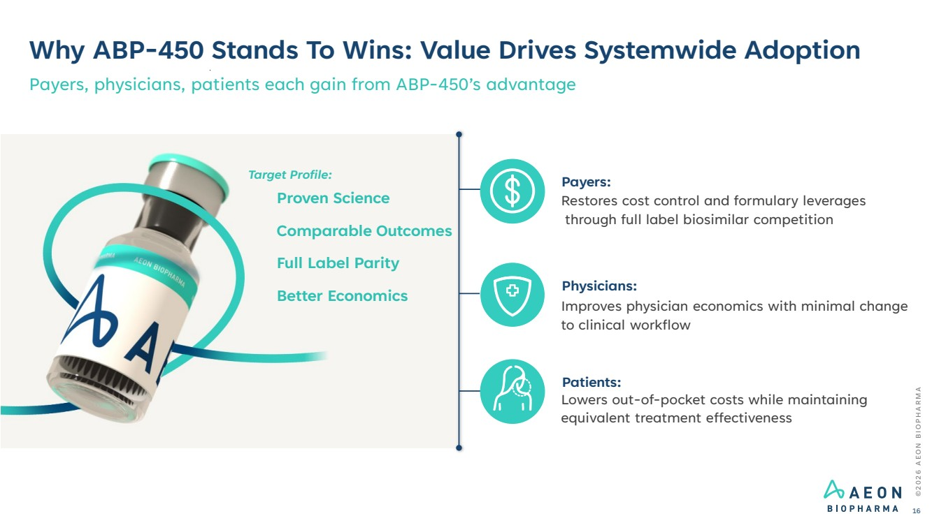 | Why ABP-450 Stands To Wins: Value Drives Systemwide Adoption Payers, physicians, patients each gain from ABP-450’s advantage Payers: Restores cost control and formulary leverages through full label biosimilar competition Physicians: Improves physician economics with minimal change to clinical workflow Patients: Lowers out-of-pocket costs while maintaining equivalent treatment effectiveness Proven Science Comparable Outcomes Full Label Parity Better Economics ©2026 AEON BIOPHARMA 16 Target Profile:
 | 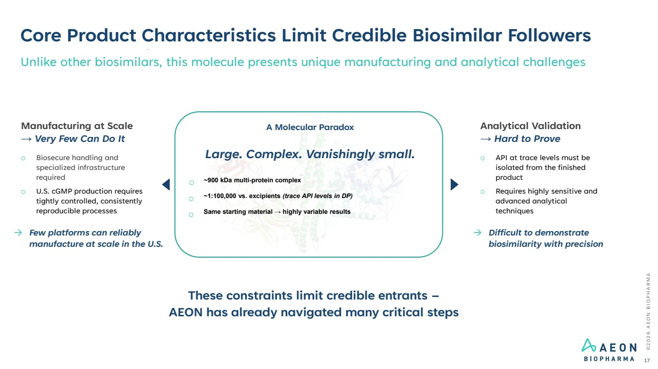 | ©2026 AEON BIOPHARMA Core Product Characteristics Limit Credible Biosimilar Followers 17 Unlike other biosimilars, this molecule presents unique manufacturing and analytical challenges A Molecular Paradox Large. Complex. Vanishingly small. o ~900 kDa multi-protein complex o ~1:100,000 vs. excipients (trace API levels in DP) o Same starting material → highly variable results These constraints limit credible entrants – AEON has already navigated many critical steps Manufacturing at Scale → Very Few Can Do It o Biosecure handling and specialized infrastructure required o U.S. cGMP production requires tightly controlled, consistently reproducible processes → Few platforms can reliably manufacture at scale in the U.S. Analytical Validation → Hard to Prove o API at trace levels must be isolated from the finished product o Requires highly sensitive and advanced analytical techniques → Difficult to demonstrate biosimilarity with precision
 | 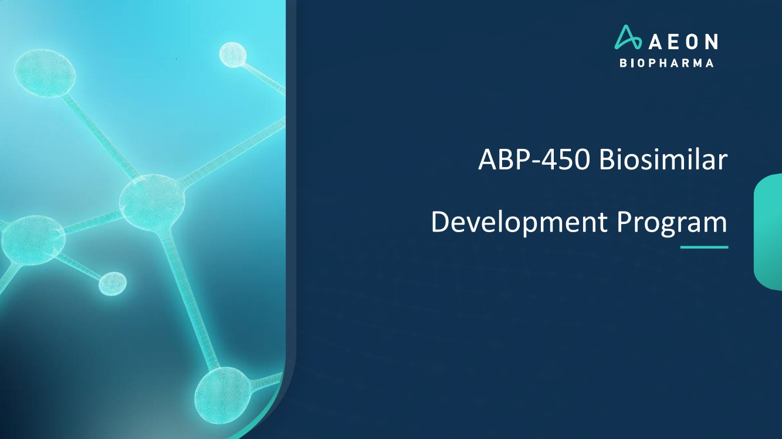 | ABP-450 Biosimilar Development Program
 | 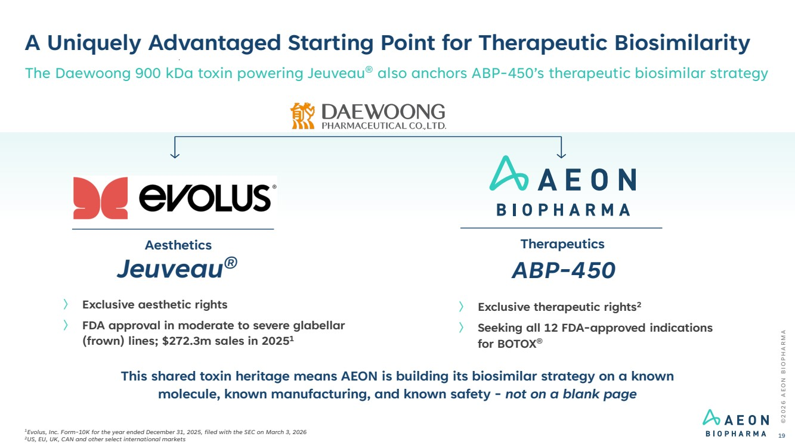 | A Uniquely Advantaged Starting Point for Therapeutic Biosimilarity 〉 Exclusive aesthetic rights 〉 FDA approval in moderate to severe glabellar (frown) lines; $272.3m sales in 20251 Jeuveau® ABP-450 Aesthetics Therapeutics 〉 Exclusive therapeutic rights2 〉 Seeking all 12 FDA-approved indications for BOTOX® ©2026 AEON BIOPHARMA 19 The Daewoong 900 kDa toxin powering Jeuveau® also anchors ABP-450’s therapeutic biosimilar strategy This shared toxin heritage means AEON is building its biosimilar strategy on a known molecule, known manufacturing, and known safety - not on a blank page 1Evolus, Inc. Form-10K for the year ended December 31, 2025, filed with the SEC on March 3, 2026 2US, EU, UK, CAN and other select international markets
 | 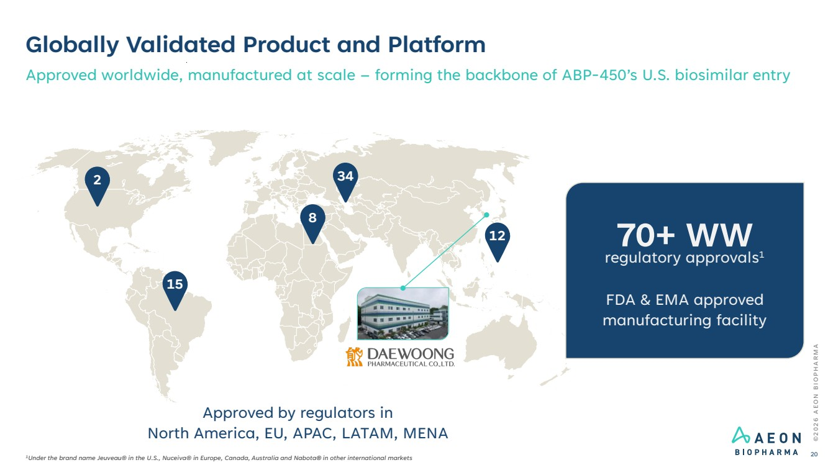 | Globally Validated Product and Platform Approved worldwide, manufactured at scale – forming the backbone of ABP-450’s U.S. biosimilar entry 2 15 8 34 12 Approved by regulators in North America, EU, APAC, LATAM, MENA ©2026 AEON BIOPHARMA 20 1Under the brand name Jeuveau® in the U.S., Nuceiva® in Europe, Canada, Australia and Nabota® in other international markets regulatory approvals 70+ WW 1 FDA & EMA approved manufacturing facility
 | 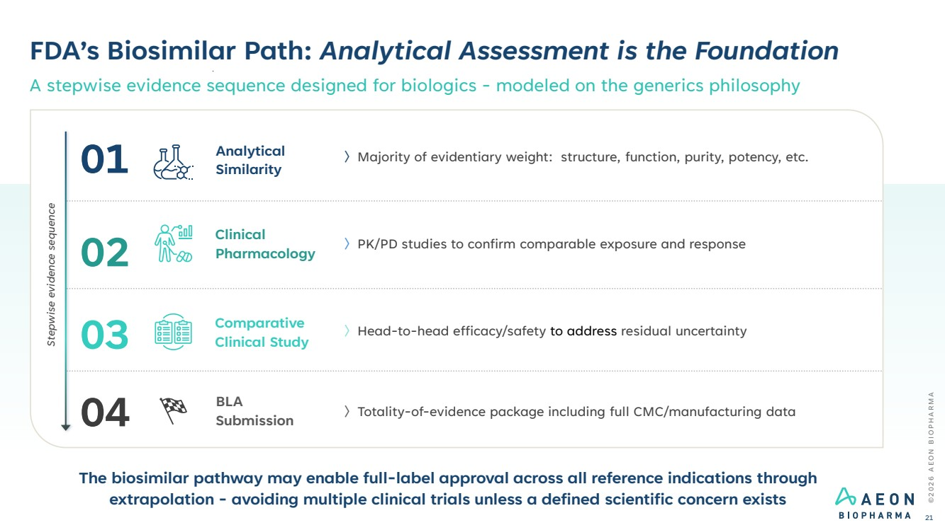 | FDA’s Biosimilar Path: Analytical Assessment is the Foundation A stepwise evidence sequence designed for biologics - modeled on the generics philosophy ©2026 AEON BIOPHARMA 21 〉Majority of evidentiary weight: structure, function, purity, potency, etc. Analytical Similarity 〉PK/PD studies to confirm comparable exposure and response Clinical Pharmacology 〉Head-to-head efficacy/safety to address residual uncertainty Comparative Clinical Study 〉Totality-of-evidence package including full CMC/manufacturing data BLA Submission The biosimilar pathway may enable full-label approval across all reference indications through extrapolation - avoiding multiple clinical trials unless a defined scientific concern exists Stepwise evidence sequence 01 02 03 04
 | 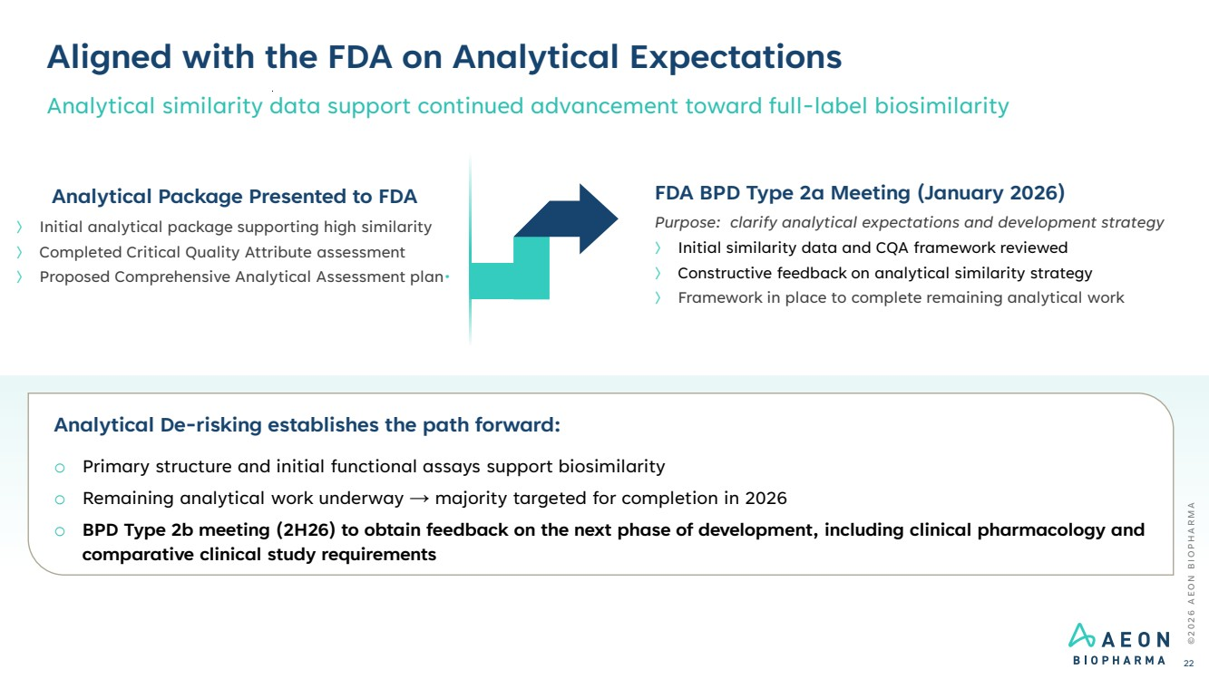 | FDA BPD Type 2a Meeting (January 2026) Purpose: clarify analytical expectations and development strategy 〉 Initial similarity data and CQA framework reviewed 〉 Constructive feedback on analytical similarity strategy 〉 Framework in place to complete remaining analytical work Analytical De-risking establishes the path forward: o Primary structure and initial functional assays support biosimilarity o Remaining analytical work underway → majority targeted for completion in 2026 o BPD Type 2b meeting (2H26) to obtain feedback on the next phase of development, including clinical pharmacology and comparative clinical study requirements Aligned with the FDA on Analytical Expectations Analytical similarity data support continued advancement toward full-label biosimilarity ©2026 AEON BIOPHARMA 22 Analytical Package Presented to FDA 〉 Initial analytical package supporting high similarity 〉 Completed Critical Quality Attribute assessment 〉 Proposed Comprehensive Analytical Assessment plan•
 | 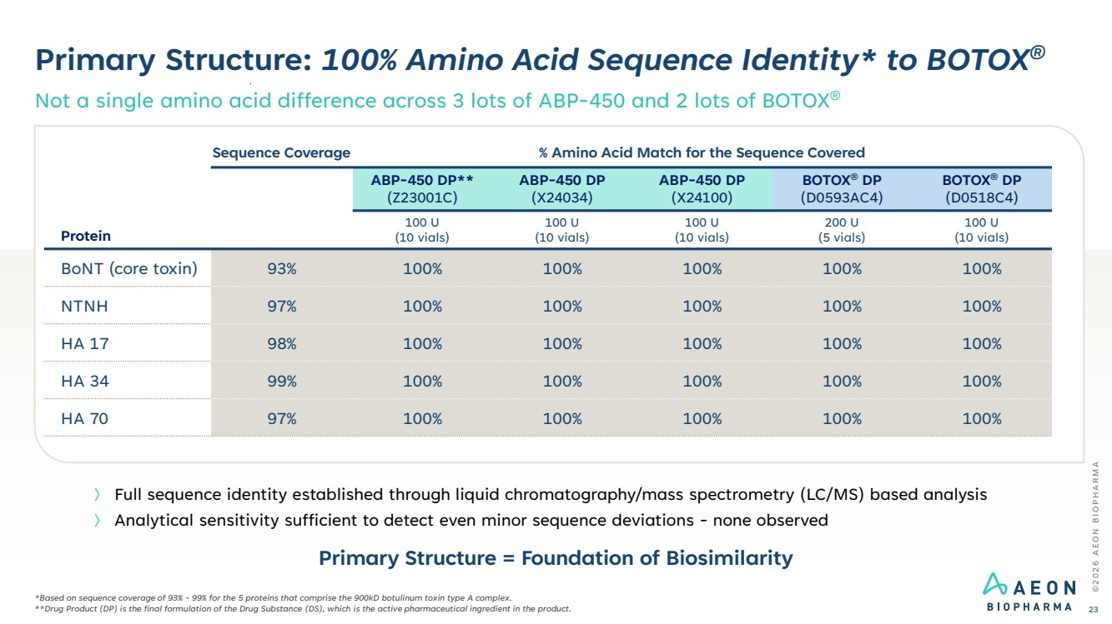 | Primary Structure: 100% Amino Acid Sequence Identity* to BOTOX® Not a single amino acid difference across 3 lots of ABP-450 and 2 lots of BOTOX® ©2026 AEON BIOPHARMA 23 *Based on sequence coverage of 93% - 99% for the 5 proteins that comprise the 900kD botulinum toxin type A complex. **Drug Product (DP) is the final formulation of the Drug Substance (DS), which is the active pharmaceutical ingredient in the product. 〉 Full sequence identity established through liquid chromatography/mass spectrometry (LC/MS) based analysis 〉 Analytical sensitivity sufficient to detect even minor sequence deviations - none observed Protein Sequence Coverage % Amino Acid Match for the Sequence Covered ABP-450 DP** (Z23001C) ABP-450 DP (X24034) ABP-450 DP (X24100) BOTOX® DP (D0593AC4) BOTOX® DP (D0518C4) 100 U (10 vials) 100 U (10 vials) 100 U (10 vials) 200 U (5 vials) 100 U (10 vials) BoNT (core toxin) 93% 100% 100% 100% 100% 100% NTNH 97% 100% 100% 100% 100% 100% HA 17 98% 100% 100% 100% 100% 100% HA 34 99% 100% 100% 100% 100% 100% HA 70 97% 100% 100% 100% 100% 100% Primary Structure = Foundation of Biosimilarity
 | 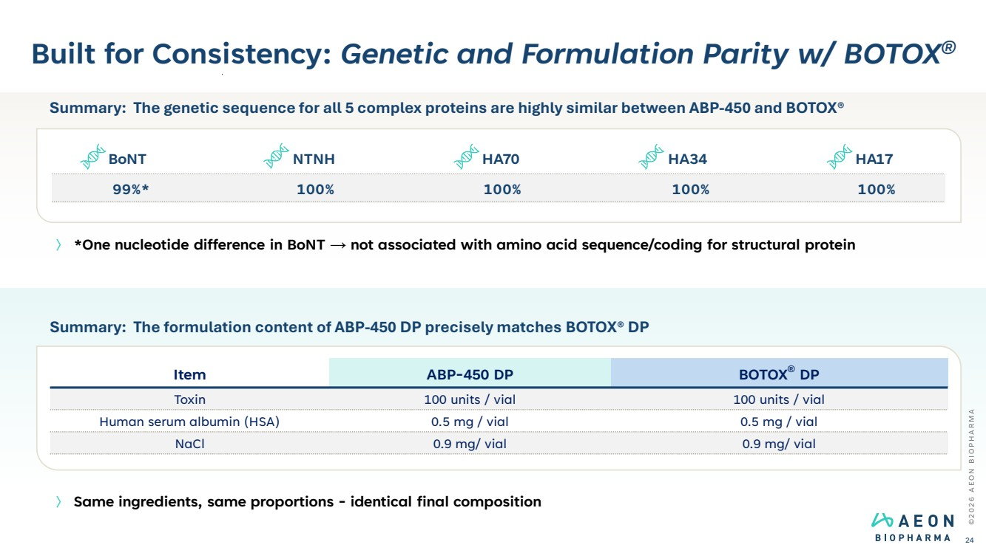 | Built for Consistency: Genetic and Formulation Parity w/ BOTOX® ©2026 AEON BIOPHARMA 24 〉 *One nucleotide difference in BoNT → not associated with amino acid sequence/coding for structural protein 〉 Same ingredients, same proportions - identical final composition Summary: The formulation content of ABP-450 DP precisely matches BOTOX® DP Item ABP-450 DP BOTOX® DP Toxin 100 units / vial 100 units / vial Human serum albumin (HSA) 0.5 mg / vial 0.5 mg / vial NaCl 0.9 mg/ vial 0.9 mg/ vial Summary: The genetic sequence for all 5 complex proteins are highly similar between ABP-450 and BOTOX® BoNT NTNH HA70 HA34 HA17 99%* 100% 100% 100% 100%
 | 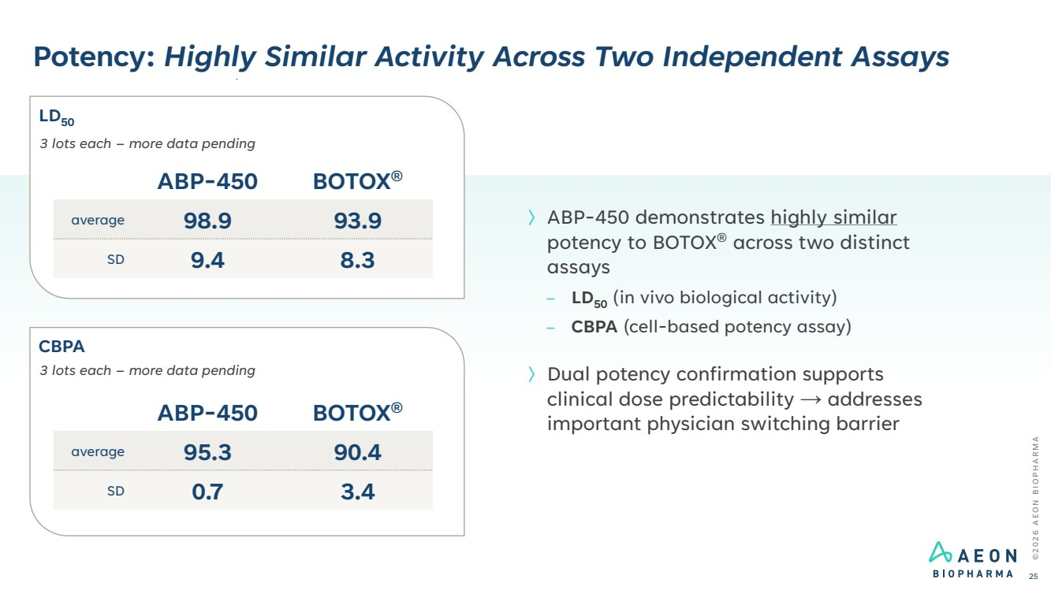 | Potency: Highly Similar Activity Across Two Independent Assays ©2026 AEON BIOPHARMA 25 〉ABP-450 demonstrates highly similar potency to BOTOX® across two distinct assays – LD50 (in vivo biological activity) – CBPA (cell-based potency assay) 〉Dual potency confirmation supports clinical dose predictability → addresses important physician switching barrier ABP-450 BOTOX® average 98.9 93.9 SD 9.4 8.3 3 lots each – more data pending ABP-450 BOTOX® average 95.3 90.4 SD 0.7 3.4 3 lots each – more data pending LD50 CBPA
 | 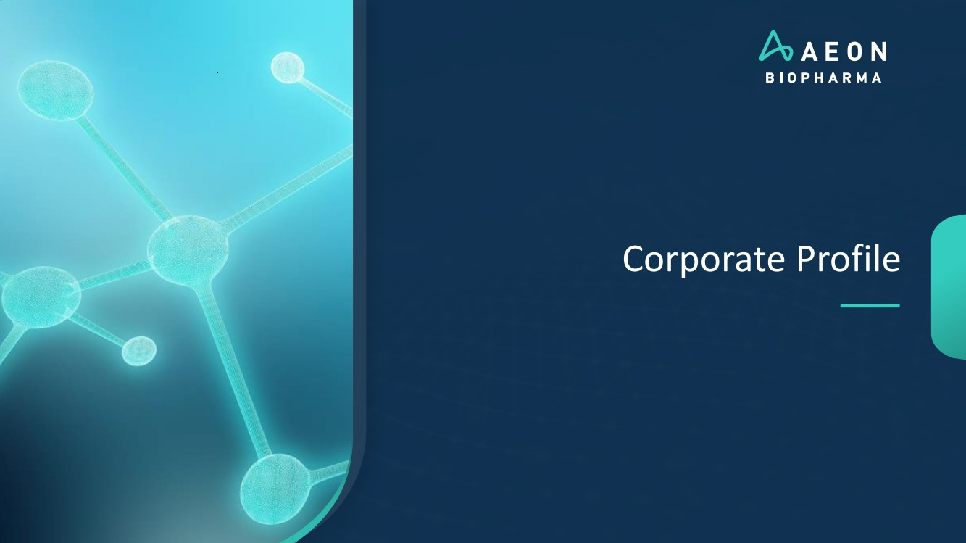 | Corporate Profile
 | 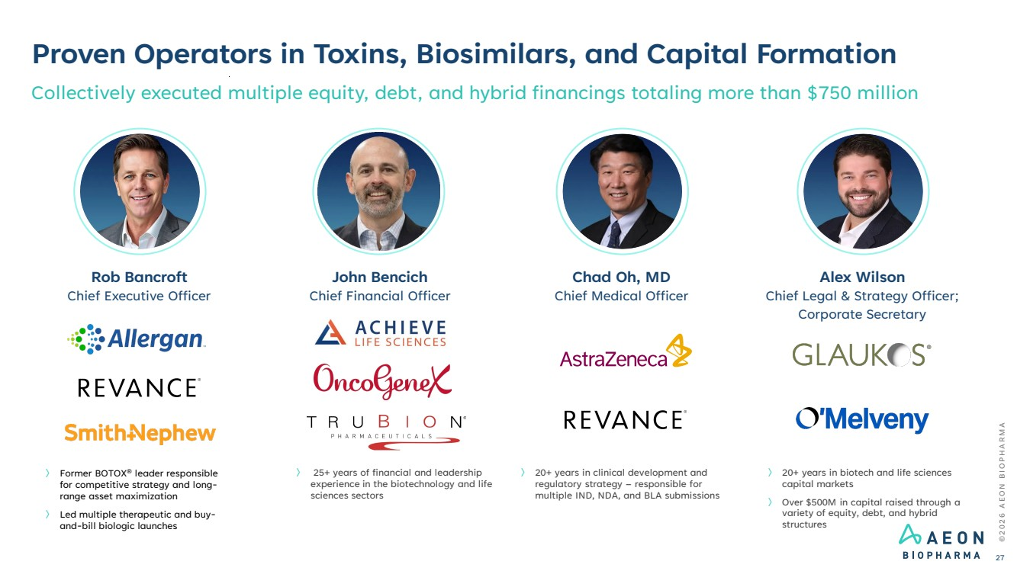 | Proven Operators in Toxins, Biosimilars, and Capital Formation Collectively executed multiple equity, debt, and hybrid financings totaling more than $750 million 〉 20+ years in biotech and life sciences capital markets 〉 Over $500M in capital raised through a variety of equity, debt, and hybrid structures Alex Wilson Chief Legal & Strategy Officer; Corporate Secretary 〉 Former BOTOX® leader responsible for competitive strategy and long-range asset maximization 〉 Led multiple therapeutic and buy-and-bill biologic launches Rob Bancroft Chief Executive Officer 〉 20+ years in clinical development and regulatory strategy – responsible for multiple IND, NDA, and BLA submissions Chad Oh, MD Chief Medical Officer ©2026 AEON BIOPHARMA 27 〉 25+ years of financial and leadership experience in the biotechnology and life sciences sectors John Bencich Chief Financial Officer
 | 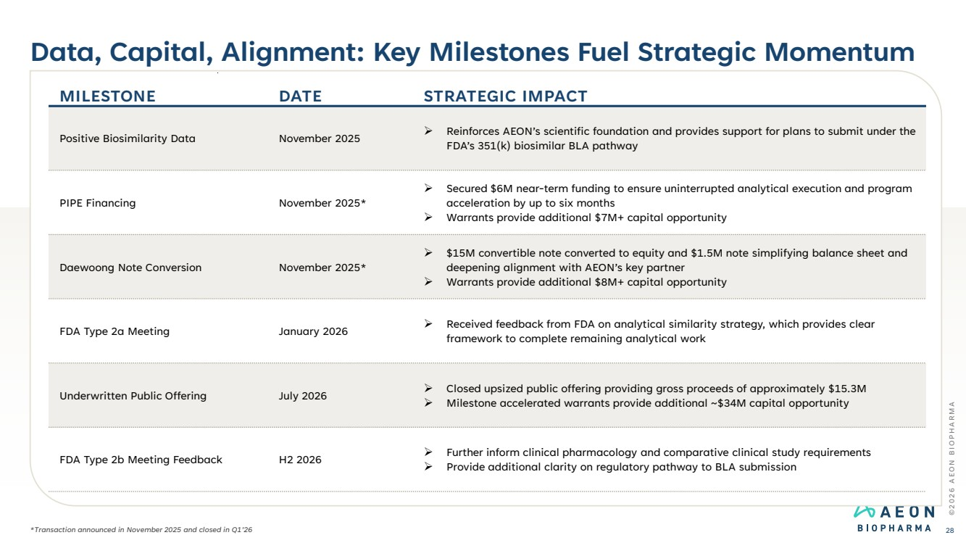 | Data, Capital, Alignment: Key Milestones Fuel Strategic Momentum ©2026 AEON BIOPHARMA 28 MILESTONE DATE STRATEGIC IMPACT Positive Biosimilarity Data November 2025 ➢ Reinforces AEON’s scientific foundation and provides support for plans to submit under the FDA’s 351(k) biosimilar BLA pathway PIPE Financing November 2025* ➢ Secured $6M near-term funding to ensure uninterrupted analytical execution and program acceleration by up to six months ➢ Warrants provide additional $7M+ capital opportunity Daewoong Note Conversion November 2025* ➢ $15M convertible note converted to equity and $1.5M note simplifying balance sheet and deepening alignment with AEON’s key partner ➢ Warrants provide additional $8M+ capital opportunity FDA Type 2a Meeting January 2026 ➢ Received feedback from FDA on analytical similarity strategy, which provides clear framework to complete remaining analytical work Underwritten Public Offering July 2026 ➢ Closed upsized public offering providing gross proceeds of approximately $15.3M ➢ Milestone accelerated warrants provide additional ~$34M capital opportunity FDA Type 2b Meeting Feedback H2 2026 ➢ Further inform clinical pharmacology and comparative clinical study requirements ➢ Provide additional clarity on regulatory pathway to BLA submission *Transaction announced in November 2025 and closed in Q1’26
 | 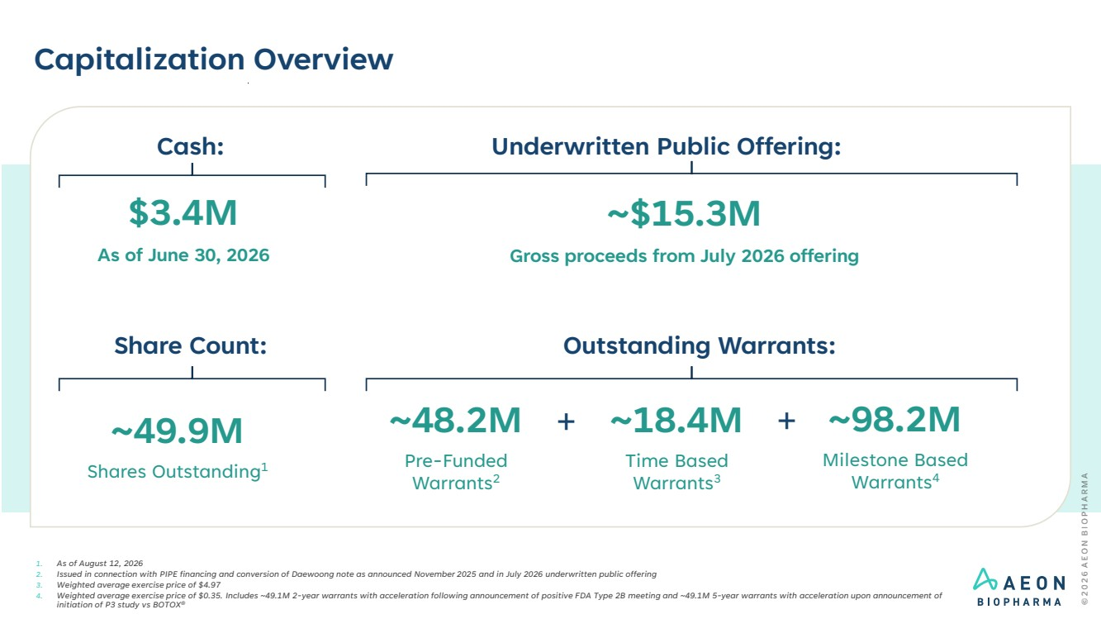 | Capitalization Overview 1. As of August 12, 2026 2. Issued in connection with PIPE financing and conversion of Daewoong note as announced November 2025 and in July 2026 underwritten public offering 3. Weighted average exercise price of $4.97 4. Weighted average exercise price of $0.35. Includes ~49.1M 2-year warrants with acceleration following announcement of positive FDA Type 2B meeting and ~49.1M 5-year warrants with acceleration upon announcement of initiation of P3 study vs BOTOX® Outstanding Warrants: ~49.9M Shares Outstanding1 ~18.4M Time Based Warrants3 ~98.2M Milestone Based Warrants4 + Share Count: ~48.2M Pre-Funded Warrants2 + Underwritten Public Offering: $3.4M As of June 30, 2026 Cash: ~$15.3M Gross proceeds from July 2026 offering
 | 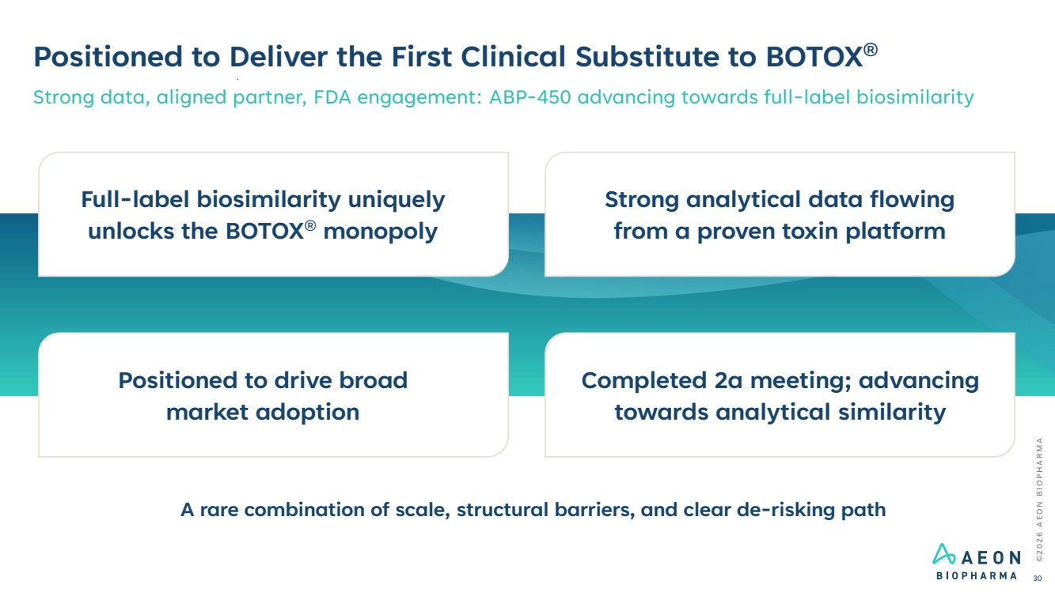 | Strong analytical data flowing from a proven toxin platform Completed 2a meeting; advancing towards analytical similarity Positioned to drive broad market adoption Full-label biosimilarity uniquely unlocks the BOTOX® monopoly ©2026 AEON BIOPHARMA 30 Positioned to Deliver the First Clinical Substitute to BOTOX® Strong data, aligned partner, FDA engagement: ABP-450 advancing towards full-label biosimilarity A rare combination of scale, structural barriers, and clear de-risking path
 | 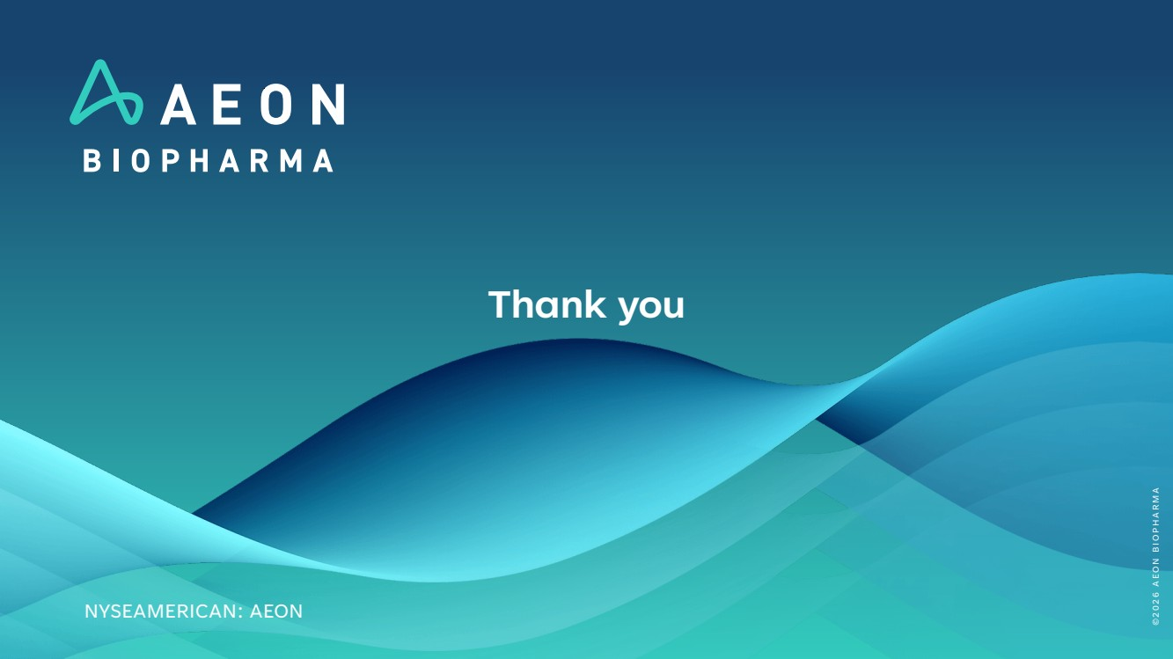 | Thank you NYSEAMERICAN: AEON ©2026 AEON BIOPHARMA

